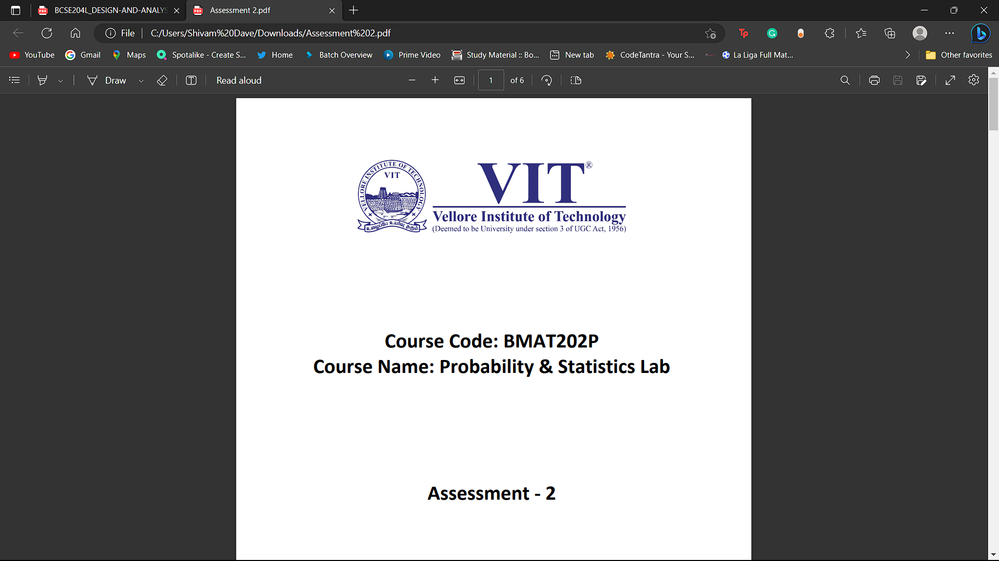

**Course Code: BCSE302P**

**Course Name: Database Systems Lab**

**Assessment – 1**

**Name: Shivam Dave**

**Reg. No.: 21BCB0107**

**DDL and DML COMMANDS**

**Aim: To study Data Definition and Data** **Manipulation commands.**

**Exercise-I:**

Create the student schema as follows

STUDENT (Regno, Fname, Lname, Phone, Address)

OUTPUT:

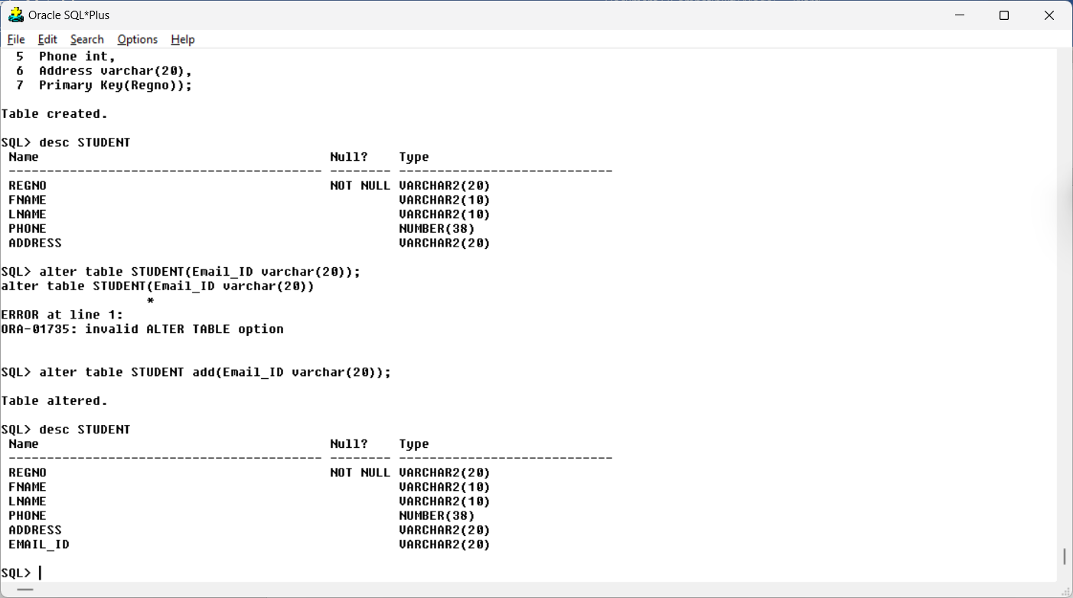

1. Add a column Email_id

Query:

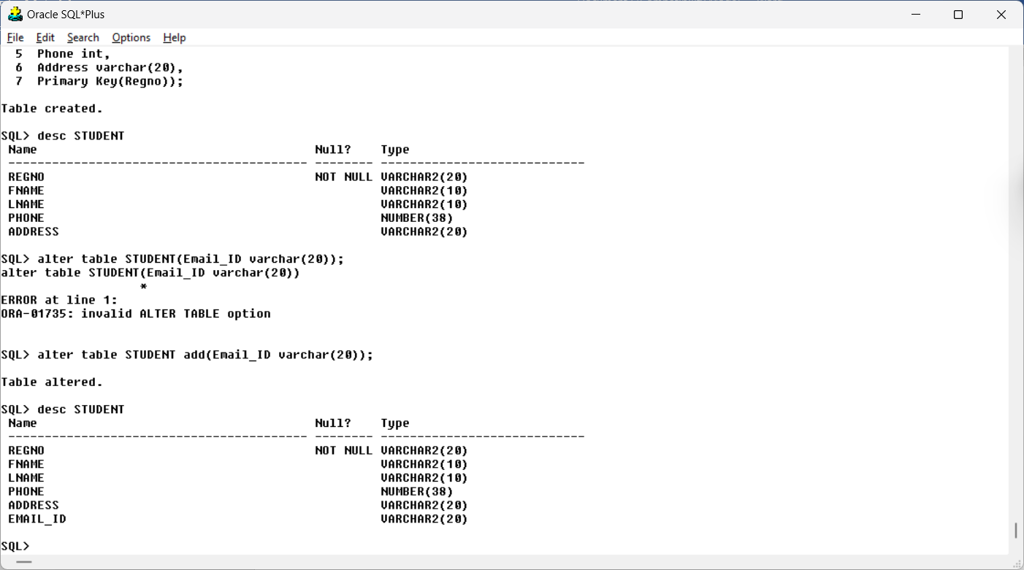

Output:

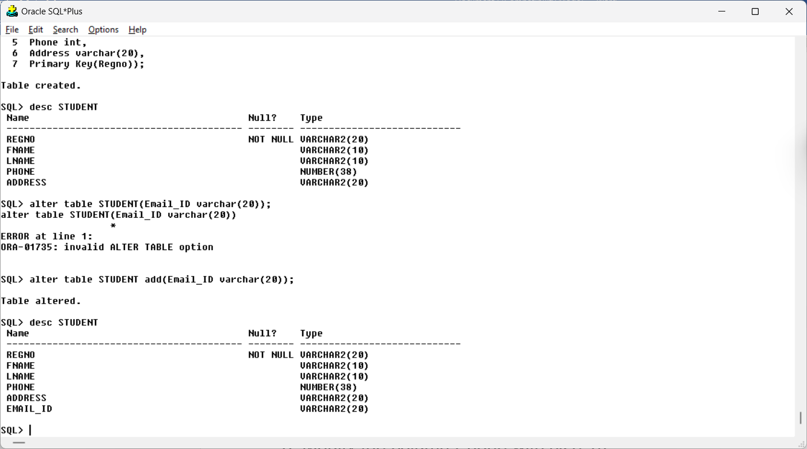

1. Remove the column Address

Query:

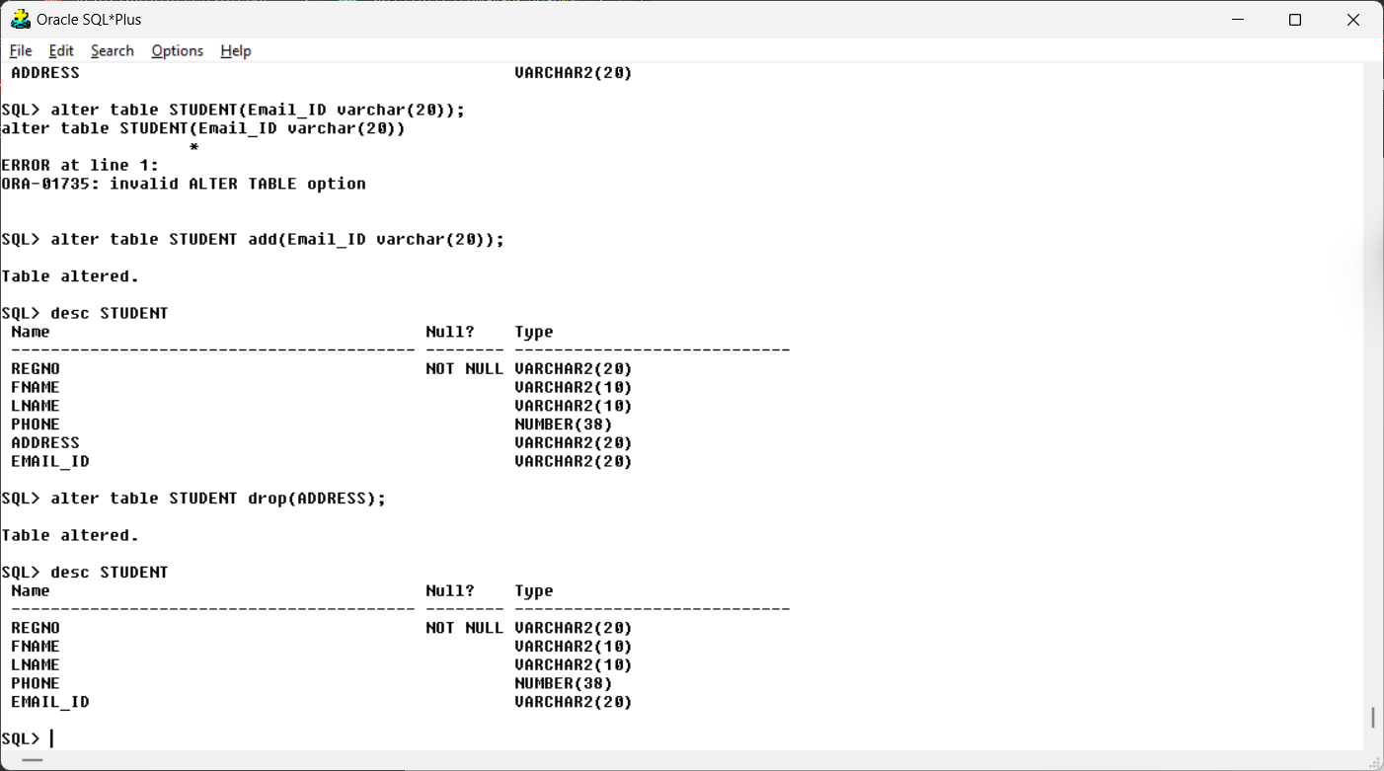

Output:



1. Modify the column Phone with size 10.

Query:

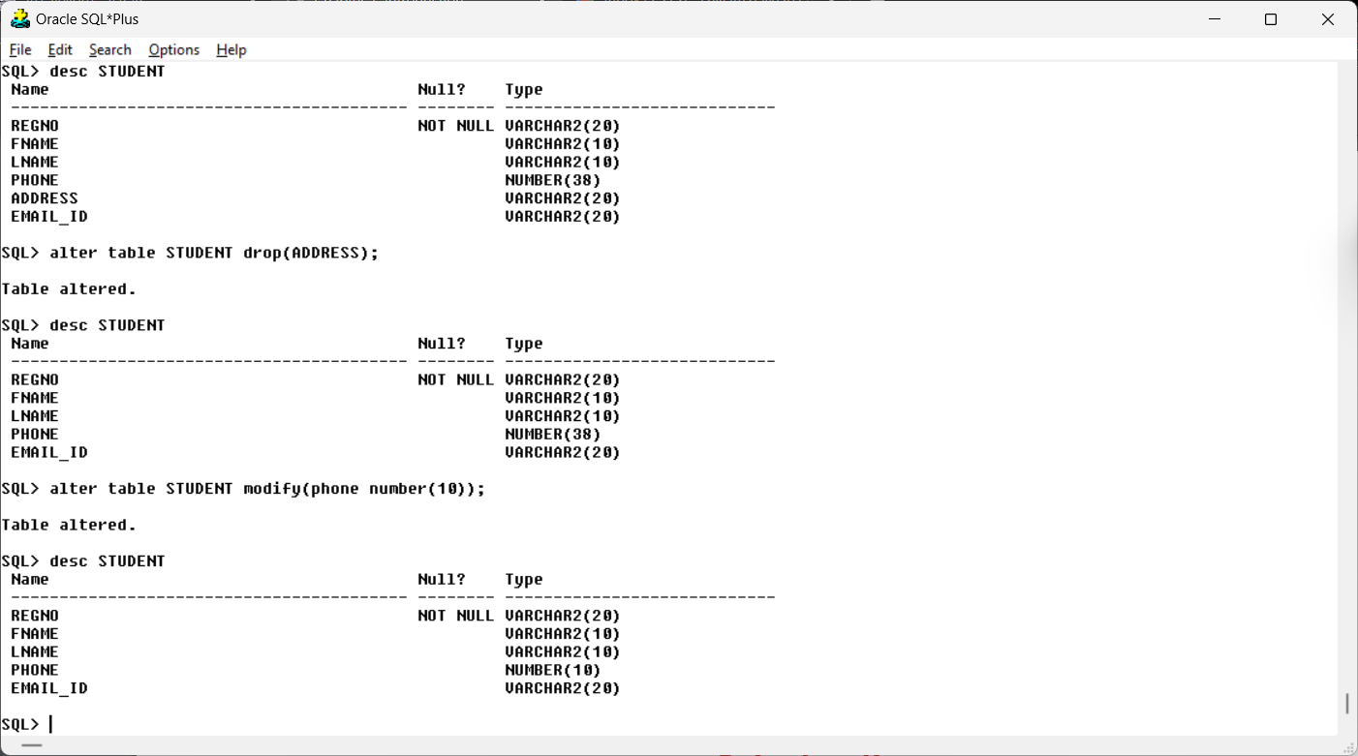

Output:



1. Rename a column Phone by Mobile_no.

Query:

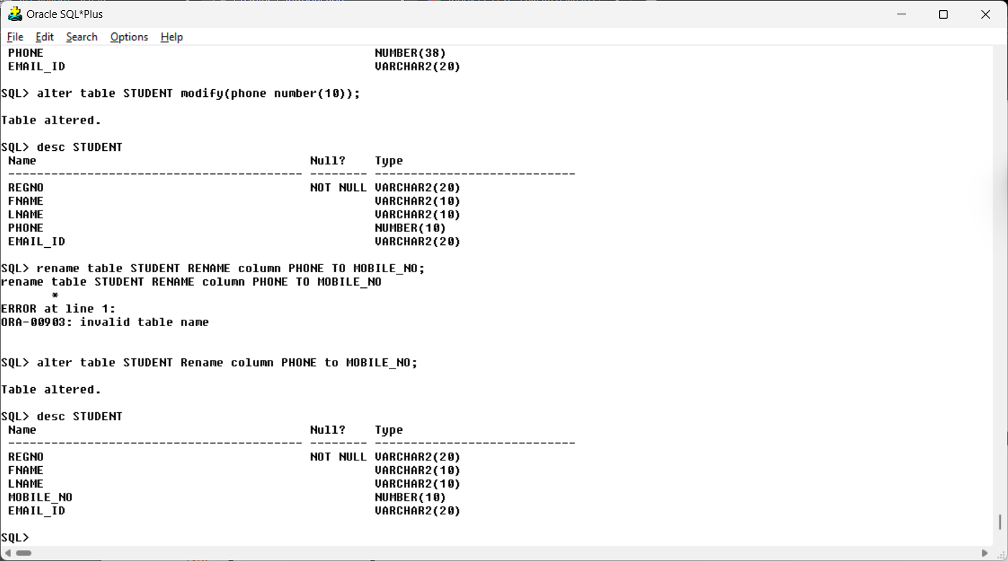

Output:



1. Rename the table name STUDENT by STUDENTS

Query:

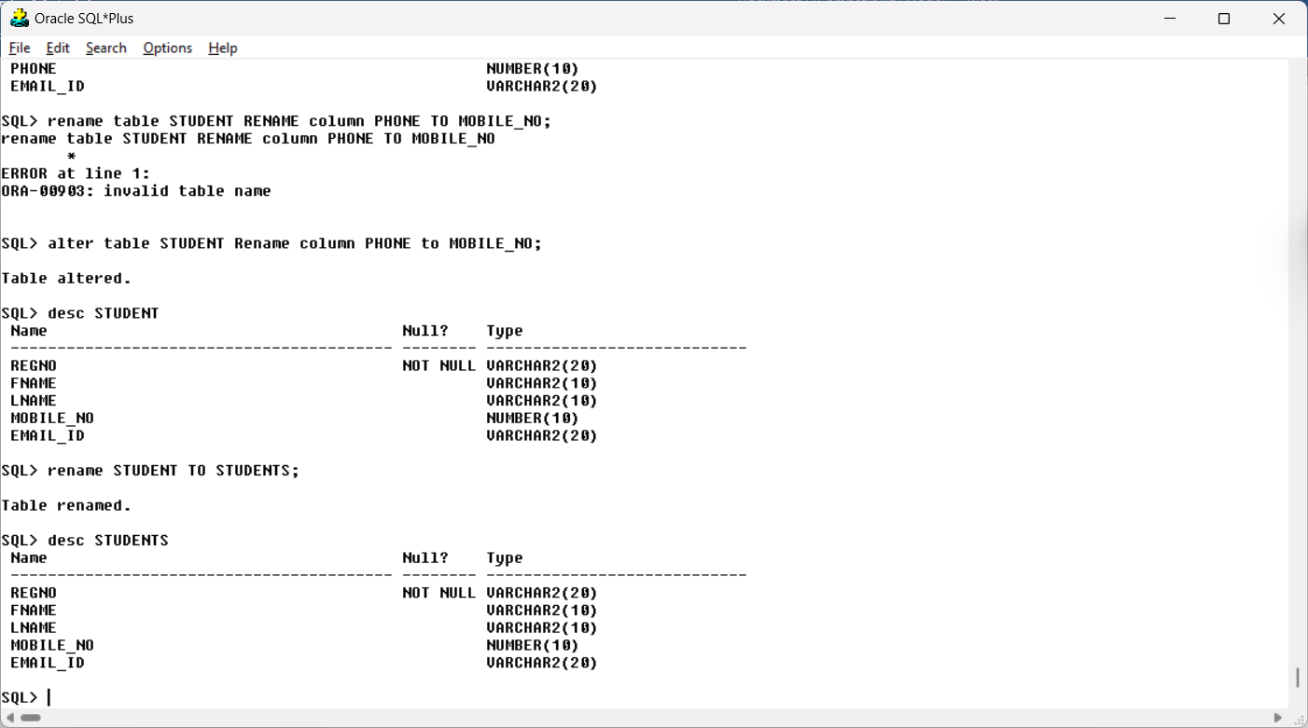

Output:



1. Insert 10 students records in STUDENTS table

Query:

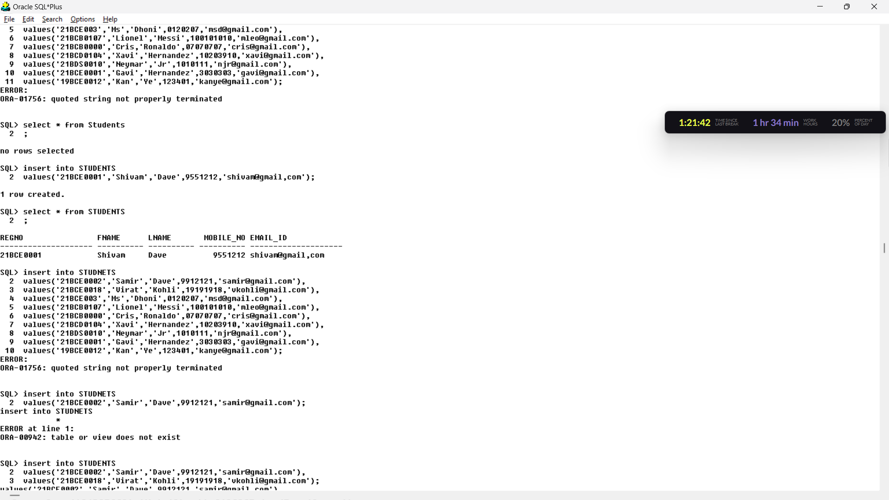

OUTPUT:

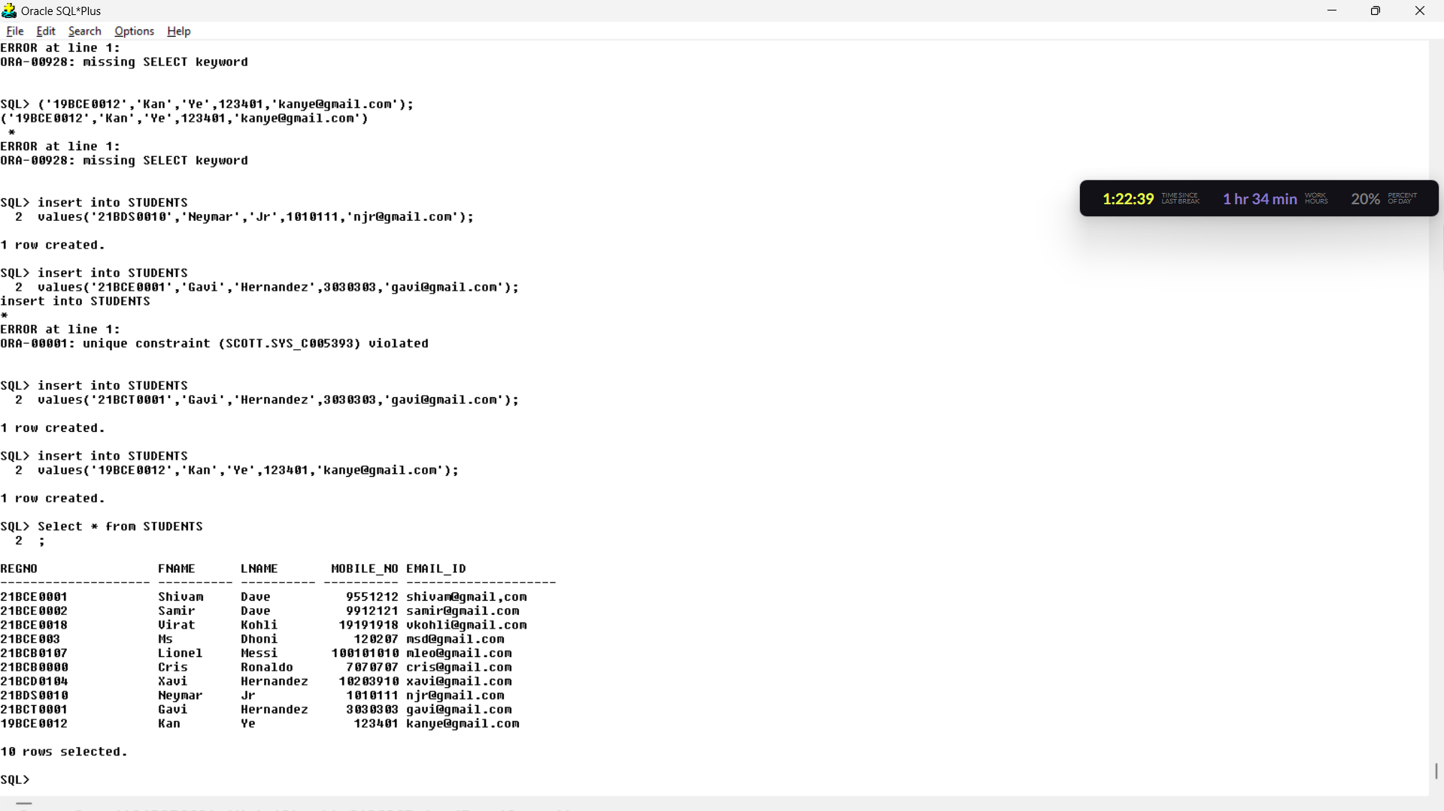

1. Show the table description

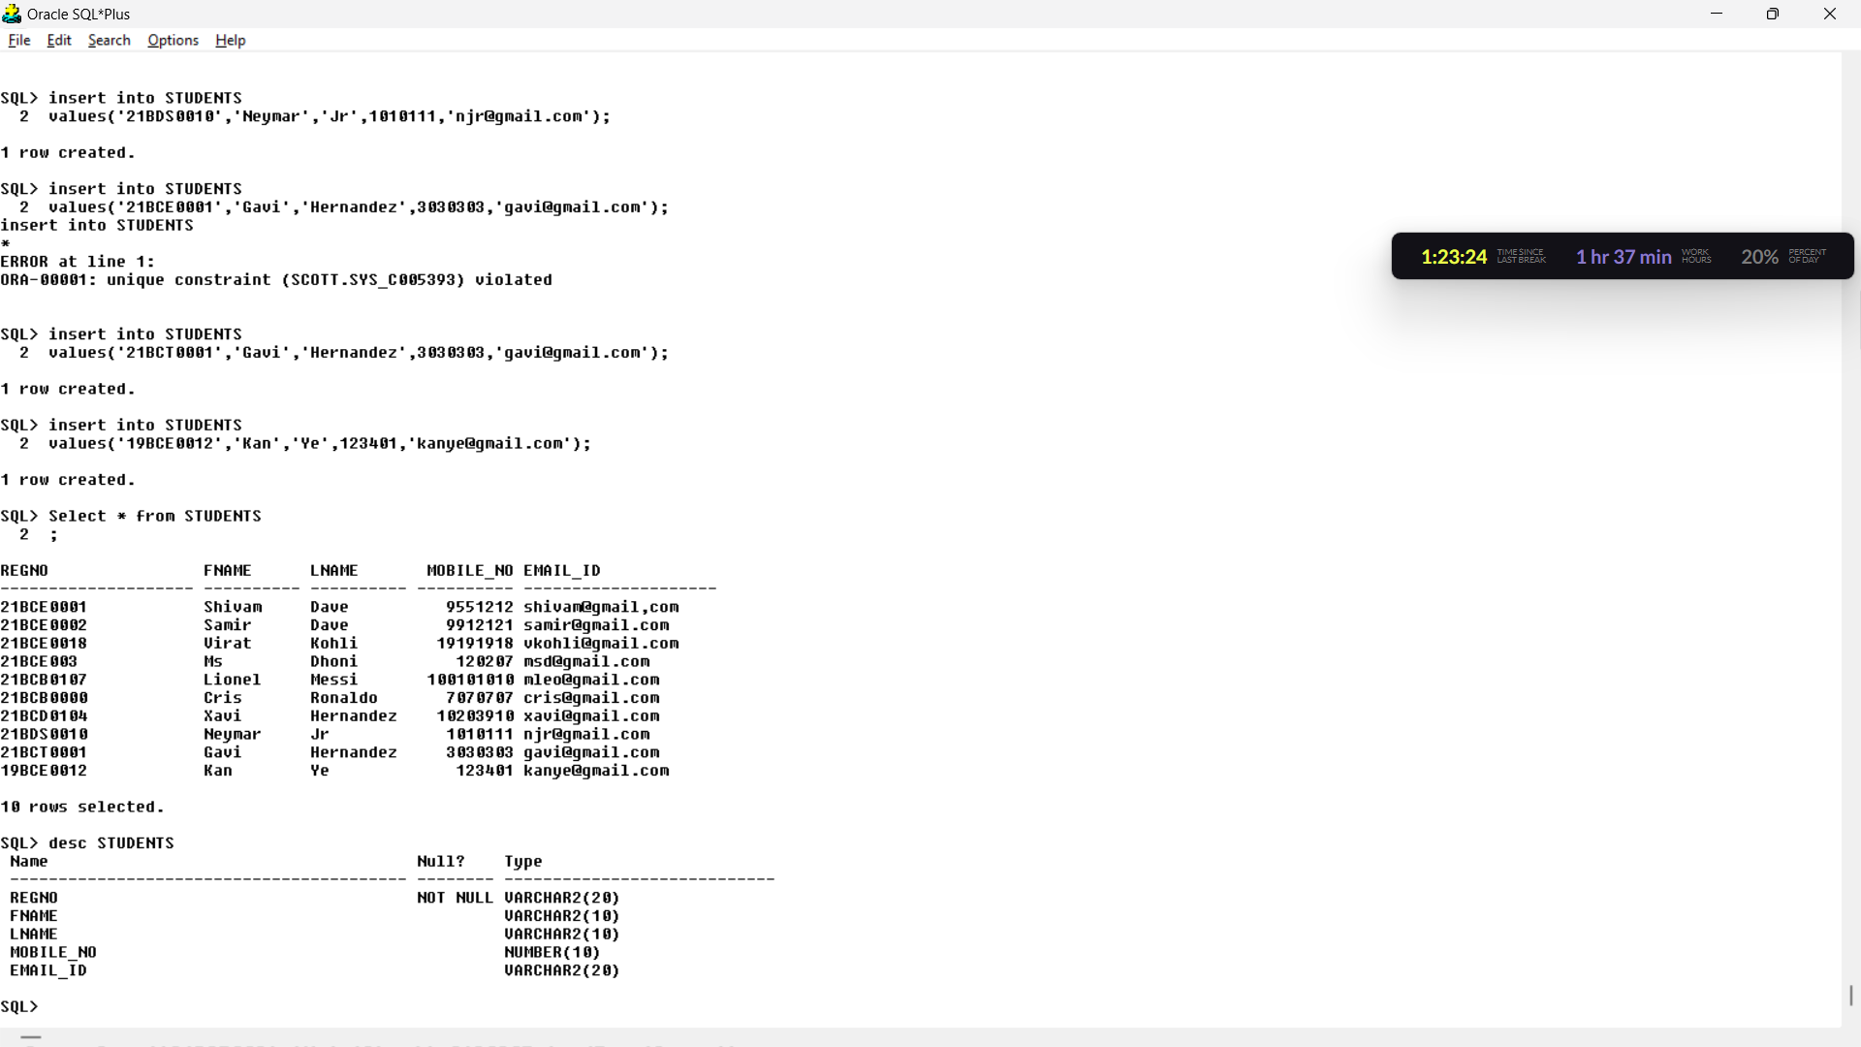

1. Display all the records



1. Delete all the records

Query:

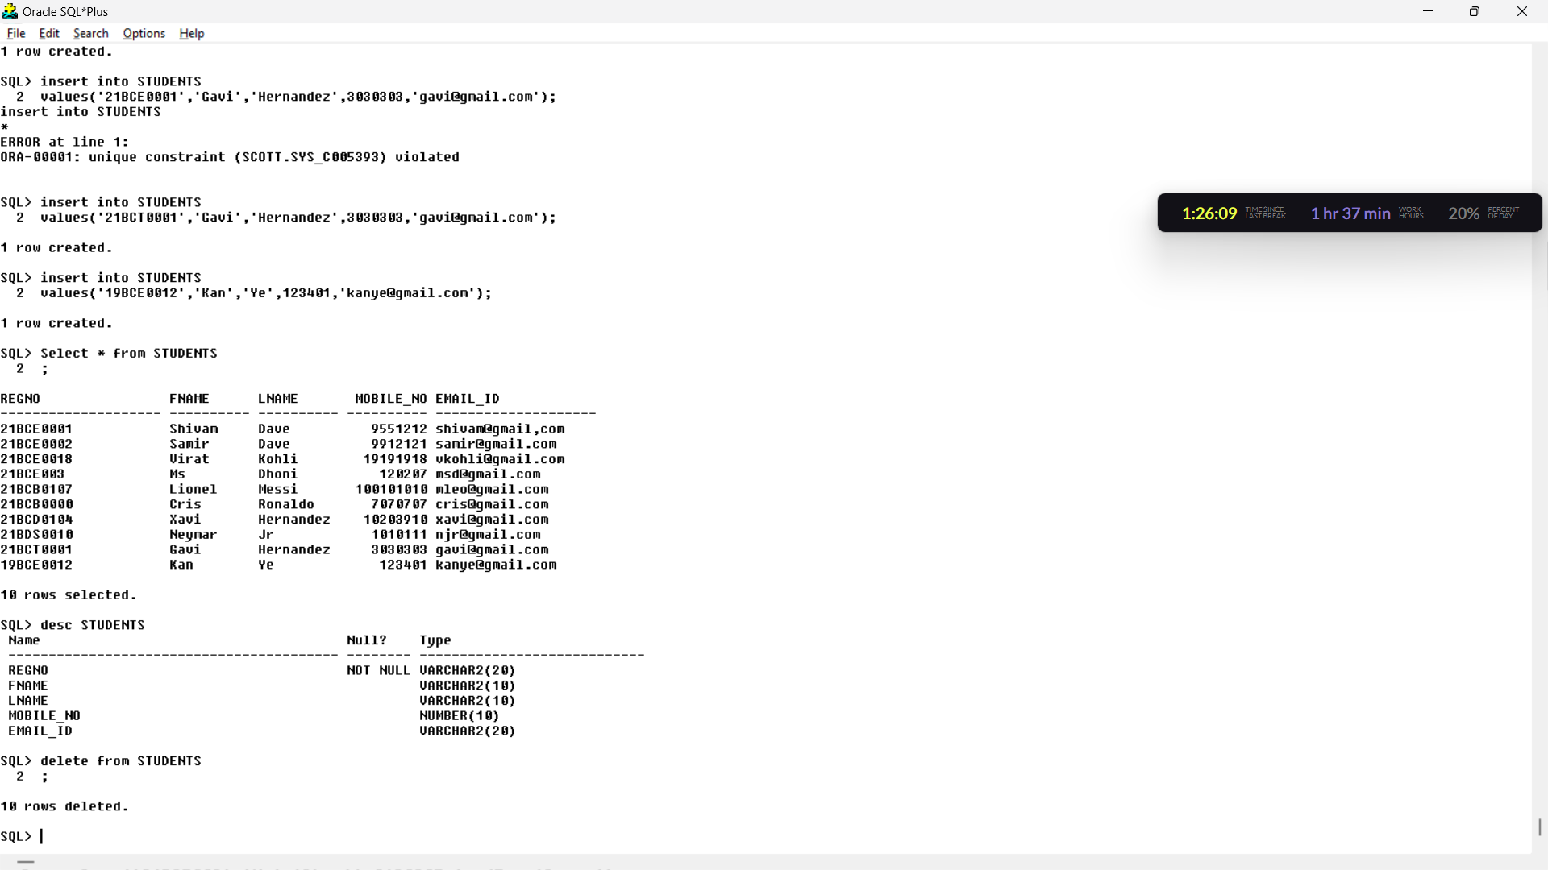

10.Drop the table

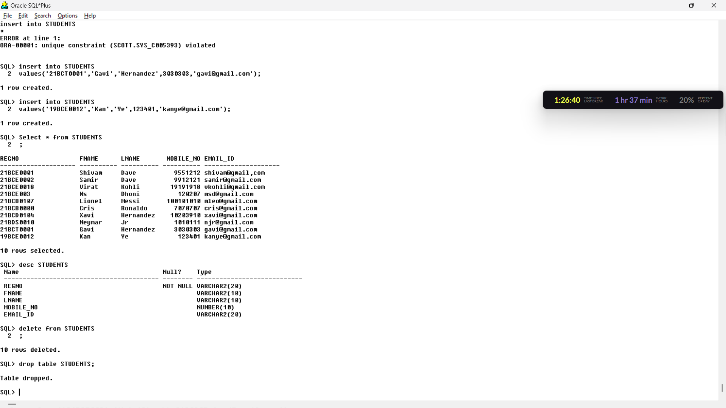

**Exercise 2:**

1. Insert the data given above in both employee, department and project tables.

Queries:

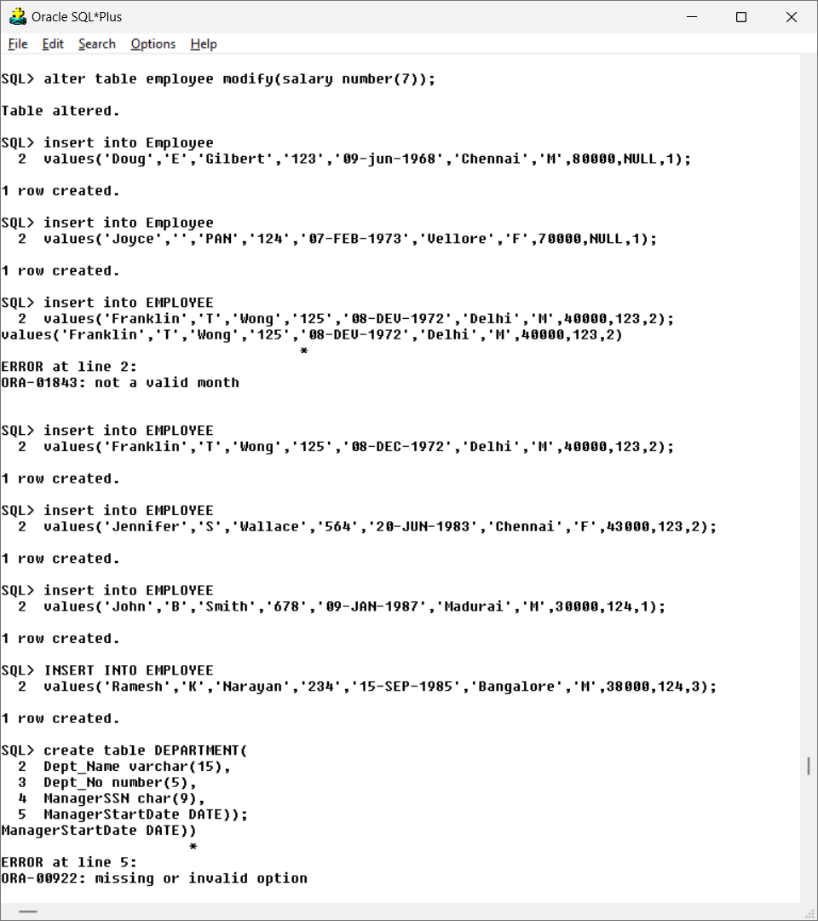

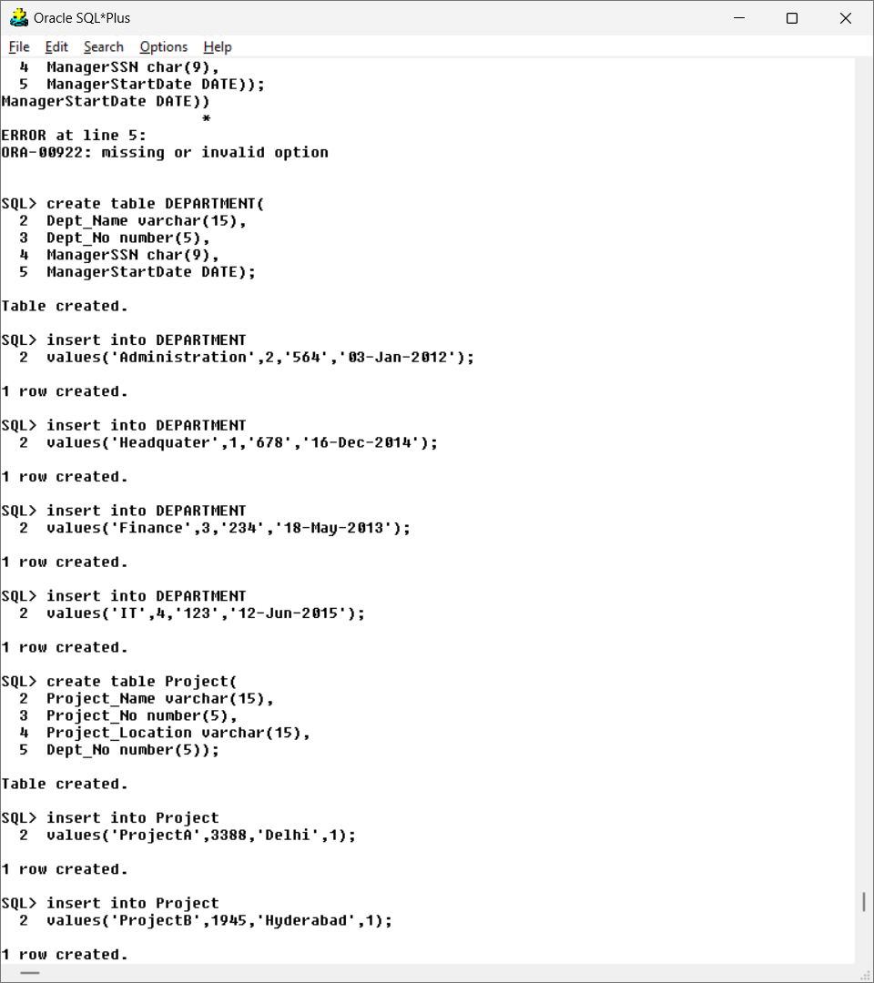

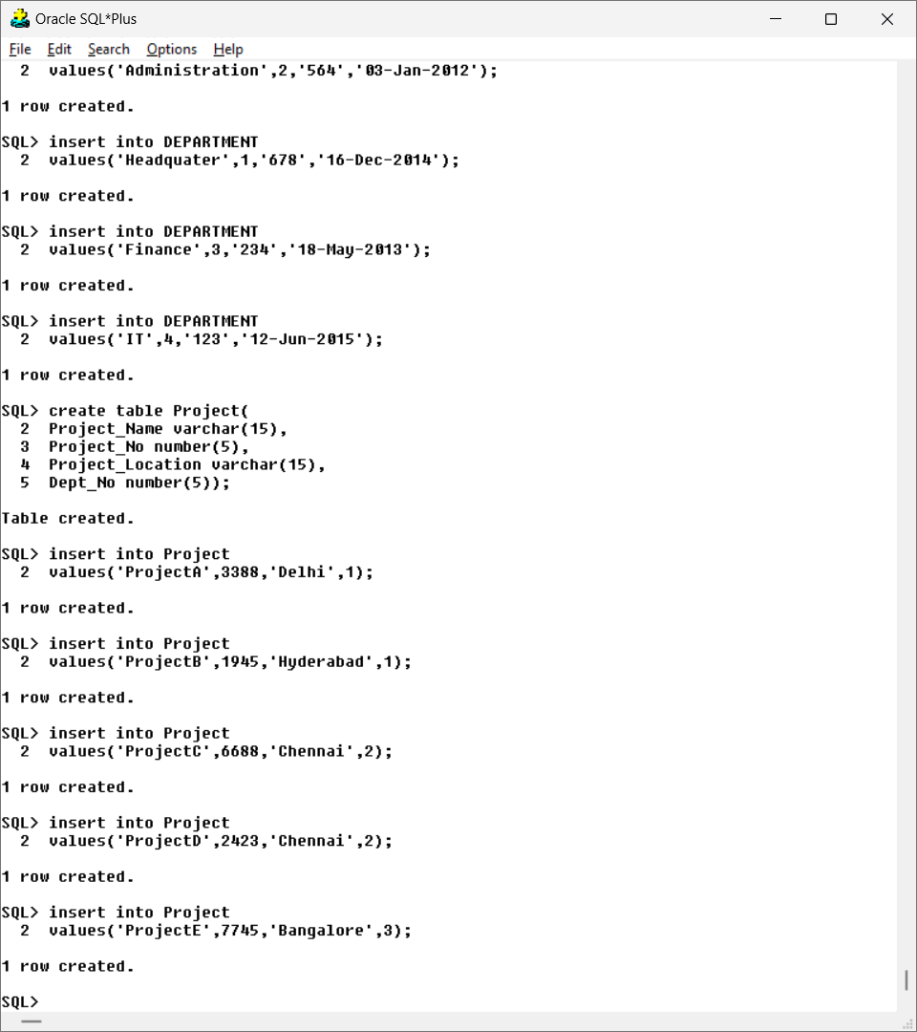

1. Display all the employees’ information.

Output:

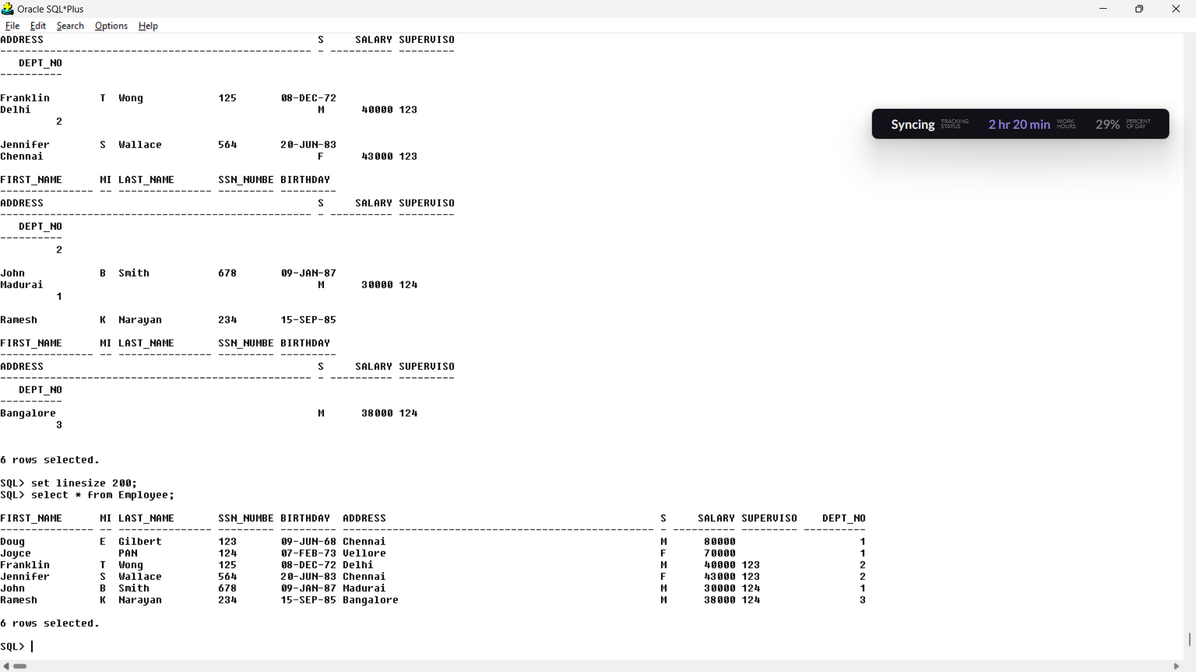

1. Display Employee name along with his SSN and Supervisor SSN.

Query:

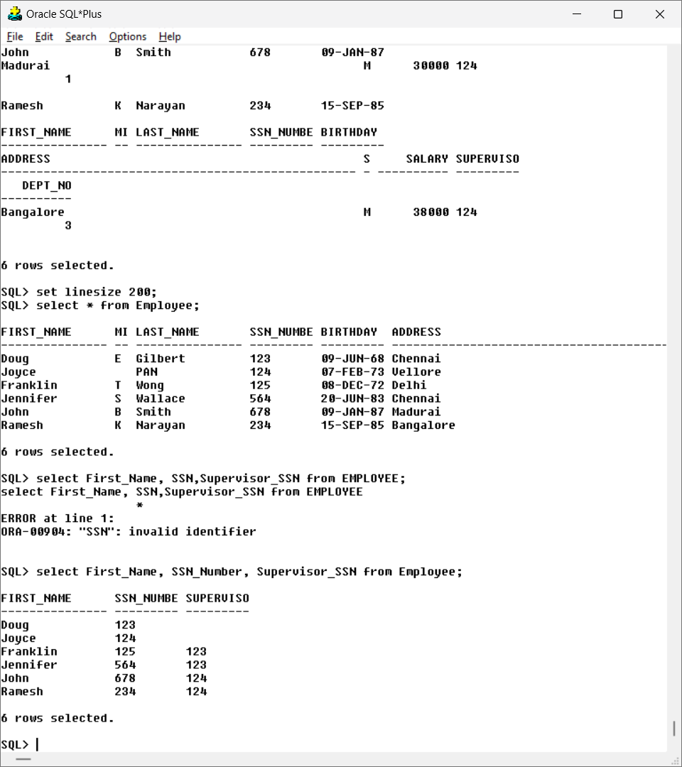

Output:



1. Display the employee names whose bdate is ’20-JUN-1983’.

Query:

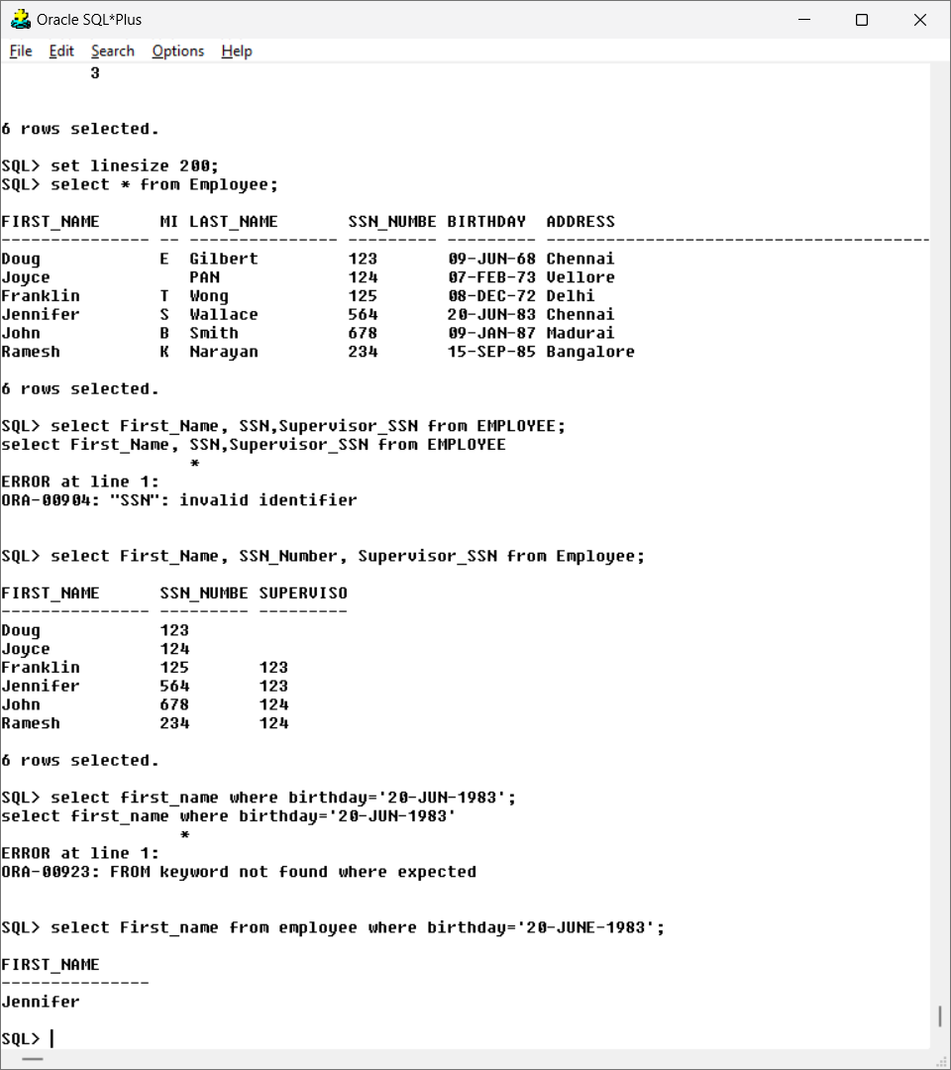

Output:



1. Display salary of the employees without duplications.

Query:

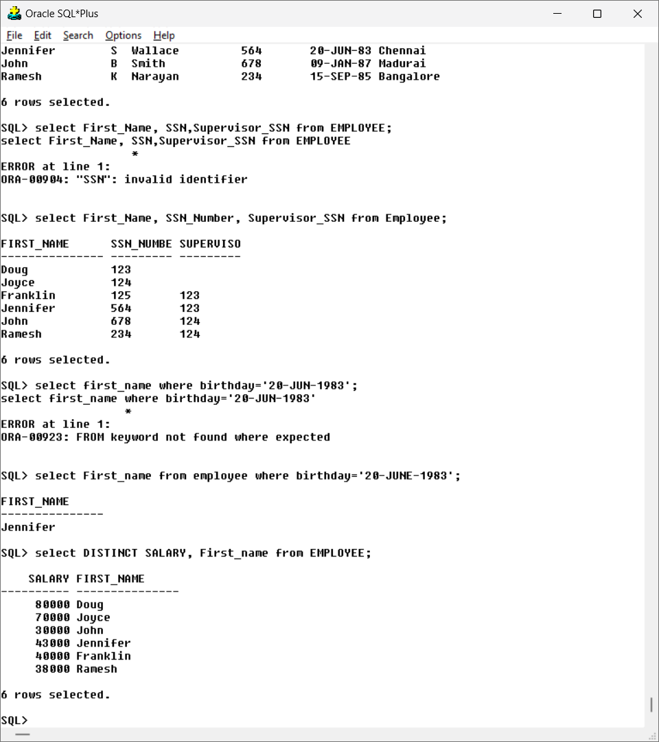

Output:



1. Display the MgrSSN, MgrStartDate of the manager of ‘Finance’ department.

Query:

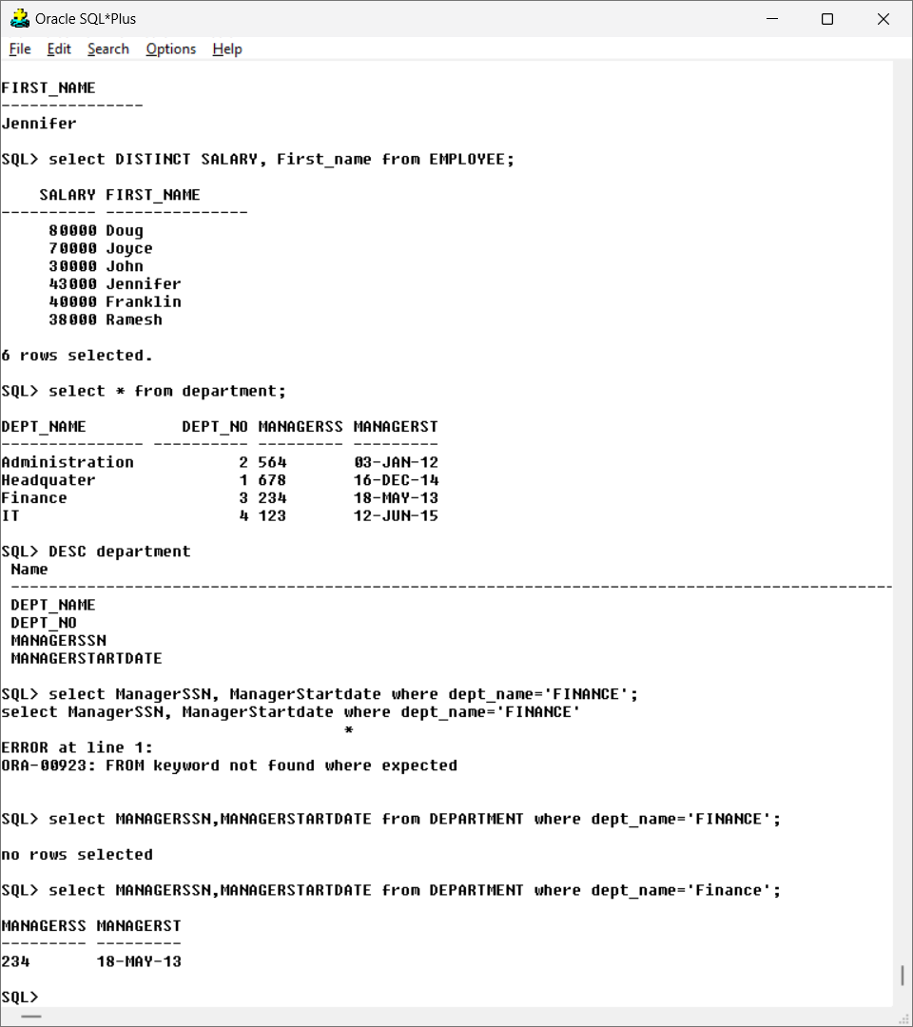

Output:



1. Modify the department number of an employee having fname as ‘Joyce’ to 5

Query:

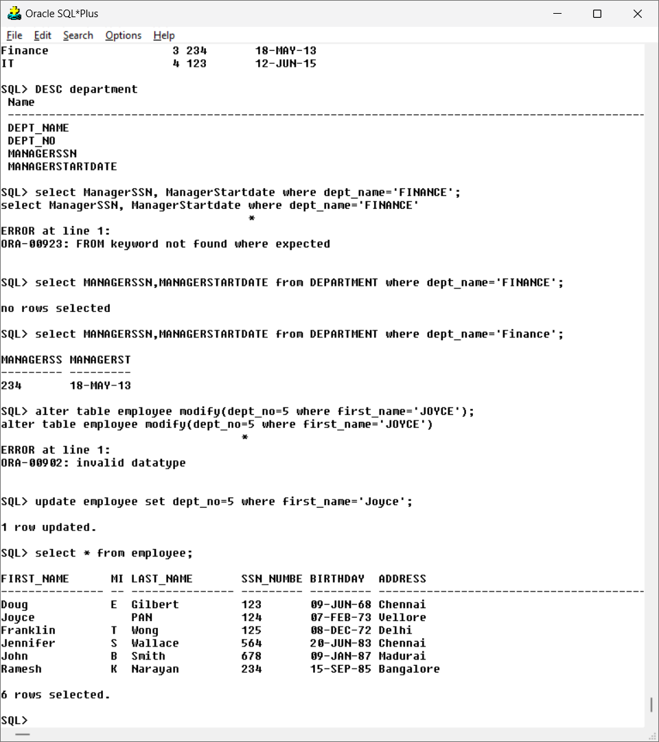

Output:



1. Alter Table department add column DepartmentPhoneNum of NUMBER data

Query:

type andinsert values into this column only. 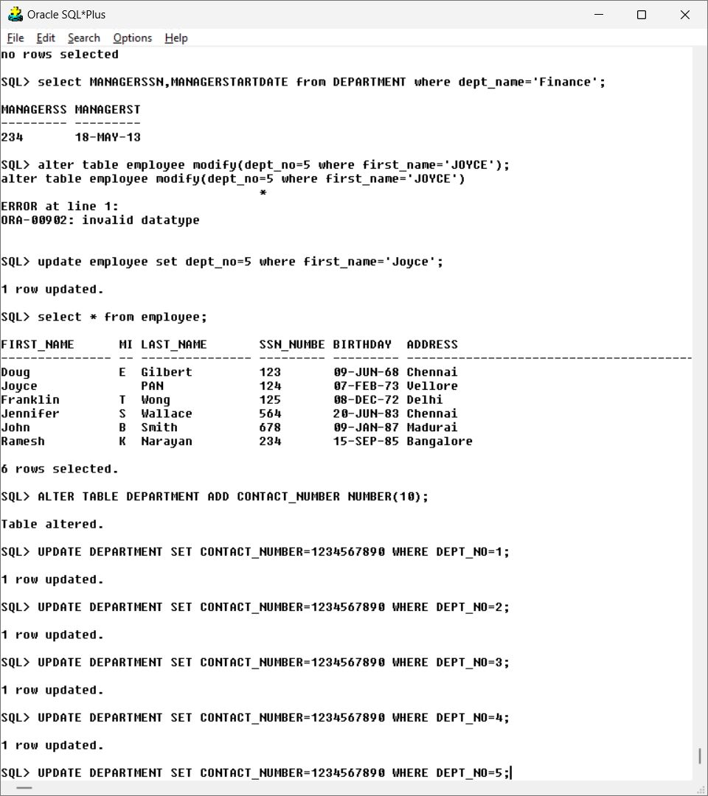

1. Alter table department to modify the size of DepartmentPhoneNum.

Query:

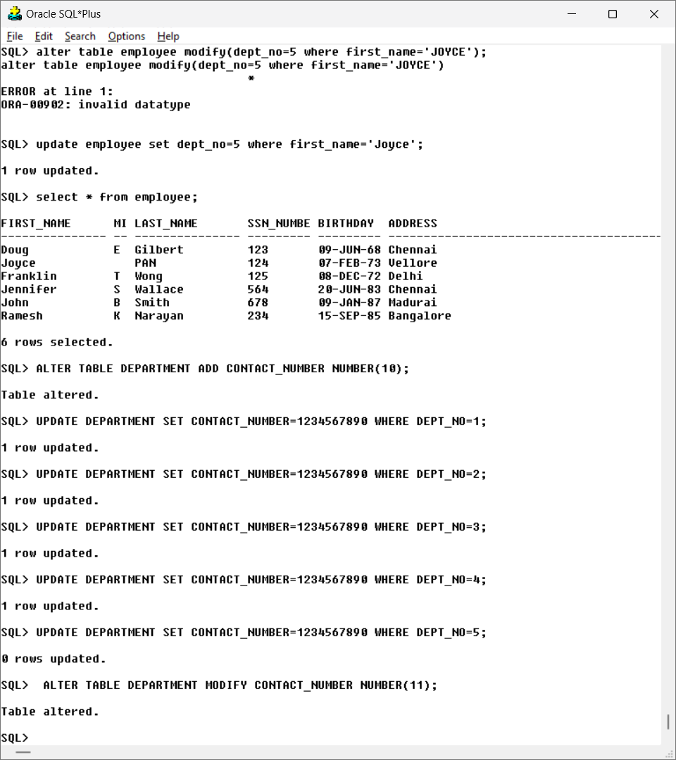

OUTPUT:

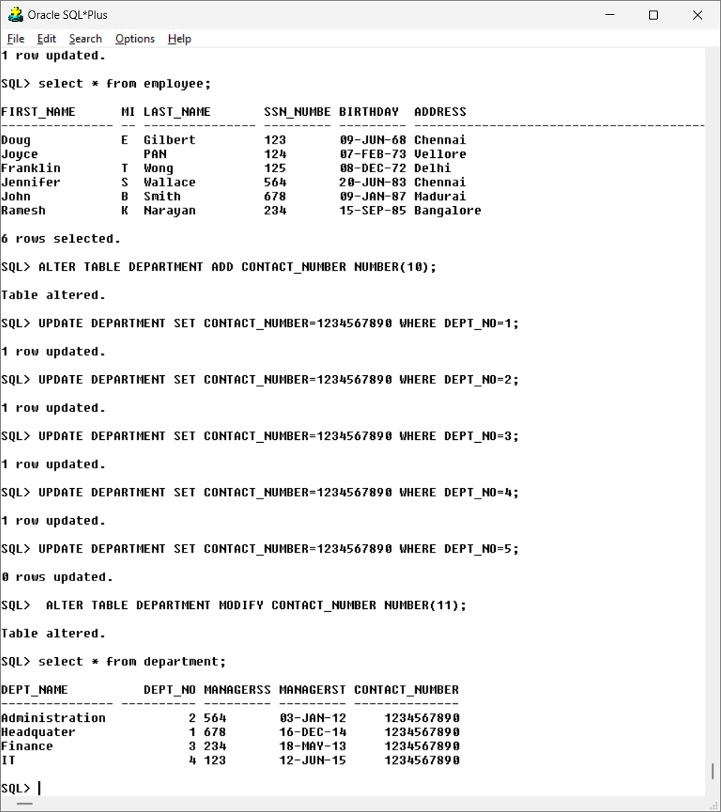

1. Modify the field name DepartmentPhoneNum of departments table to PhNo.

Query:

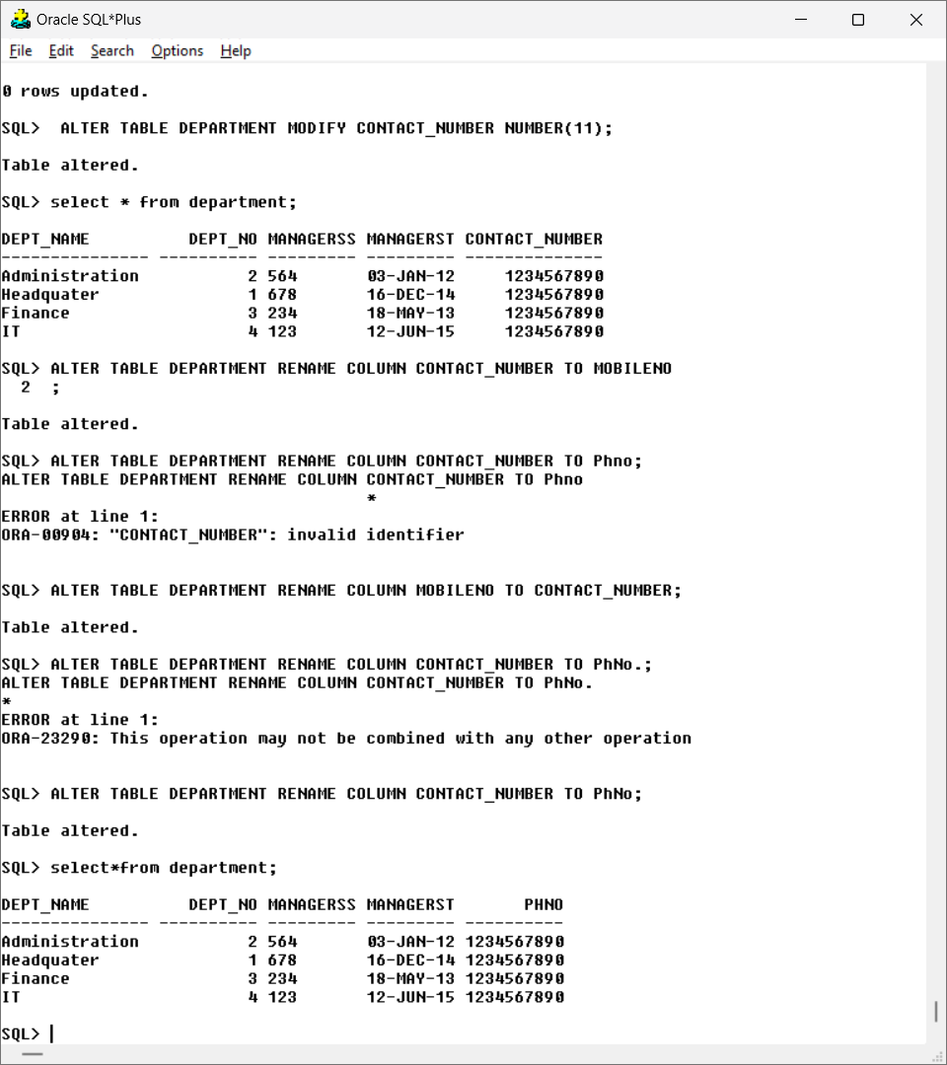

Output:



1. Rename Table Department as DEPT.

Query:

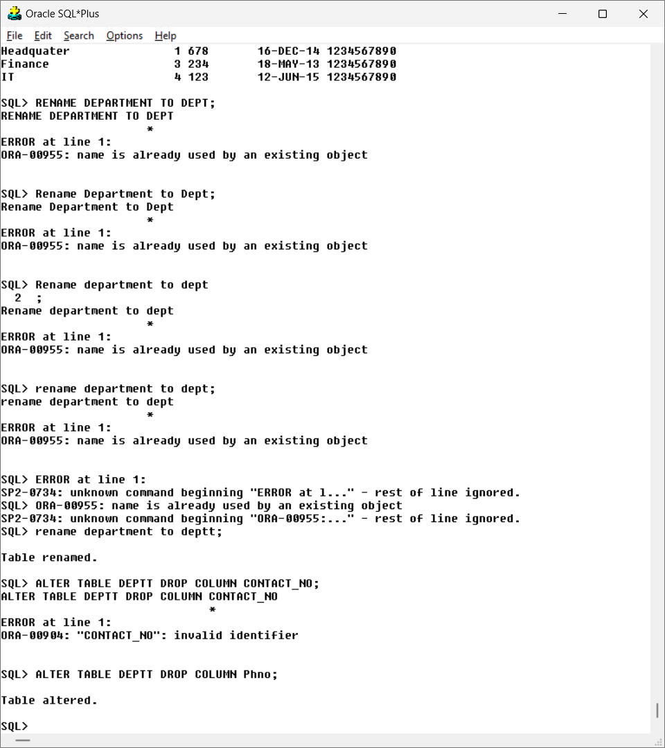

1. Alter Table department remove column PhNo.

Query:



1. Create a table COPYOFDEPT as a copy of the table DEPT.

Query:

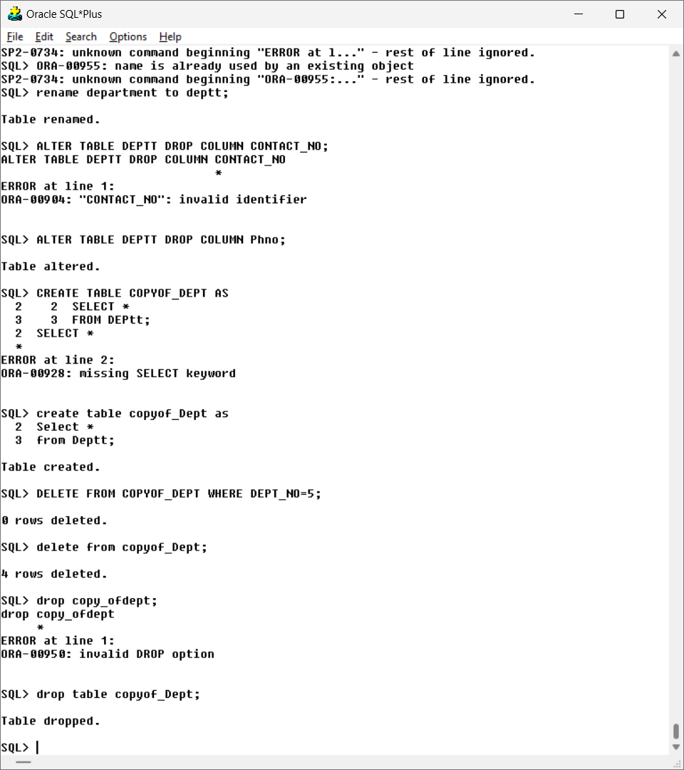

1. Delete all the rows from COPYOF DEPT table.

Query:



1. Remove COPYOF DEPT table.

Query:



**Aim: To know how the constraints are used to make table is consistent.**

**Exercise – 3:**Execute the following Query on the Db to display and discuss the integrity constraints violated by any of the following operations

1. Insert ('Robert', 'F', 'Scott', '235', '21-JUN-1990', 'Bangalore', M, 58000, '100', 1 ) into

EMPLOYEE.

Output:

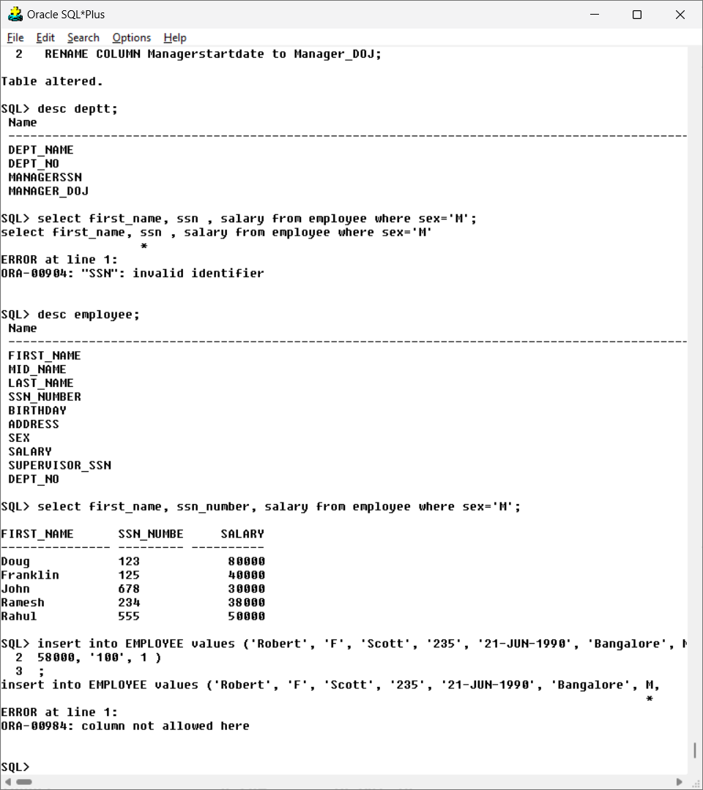

*Since department number 1 doesn’t exist, the last column is not allowed here.*

2. Insert ( 'ProjectF', null, 'Chennai', 3 ) into Project.

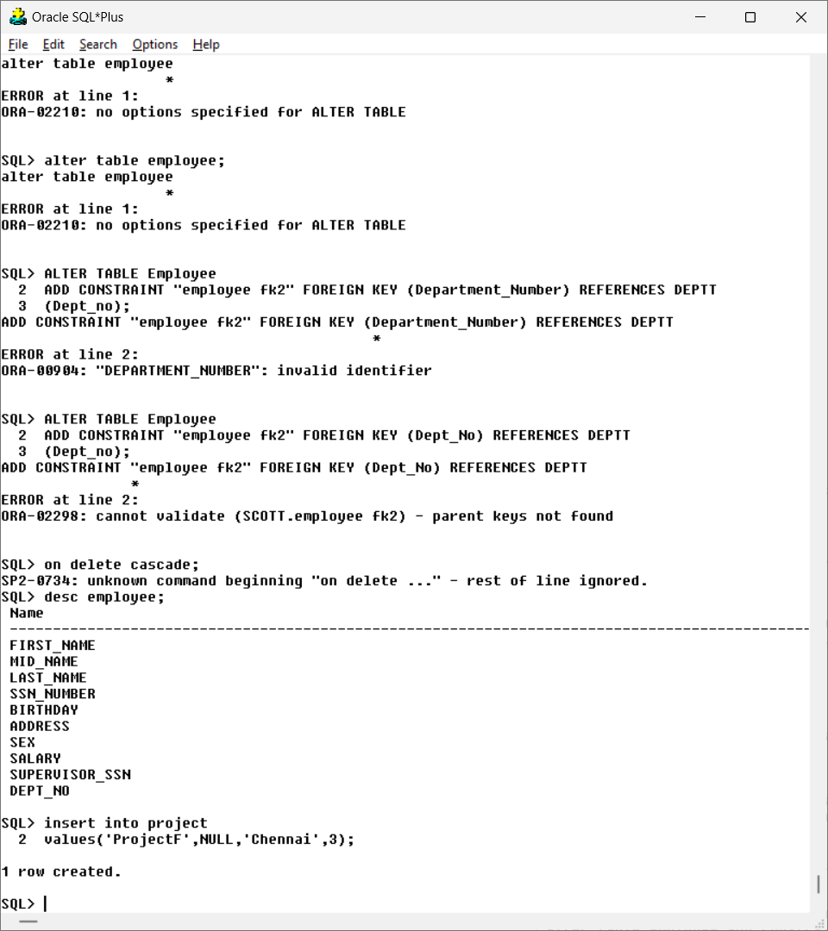

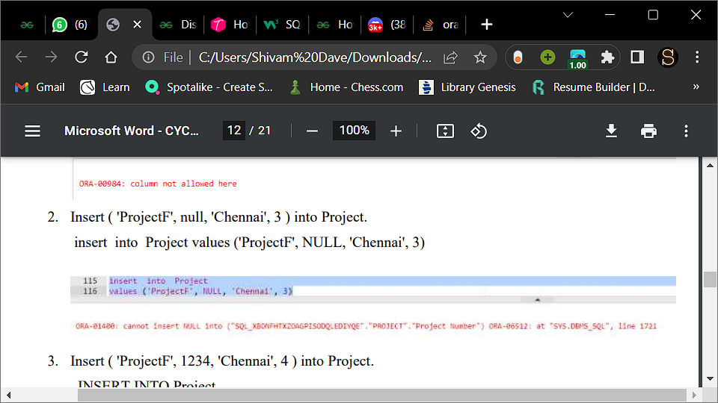

*Project name cannot be set as null*

3. Insert ( 'ProjectF', 1234, 'Chennai', 4 ) into Project.

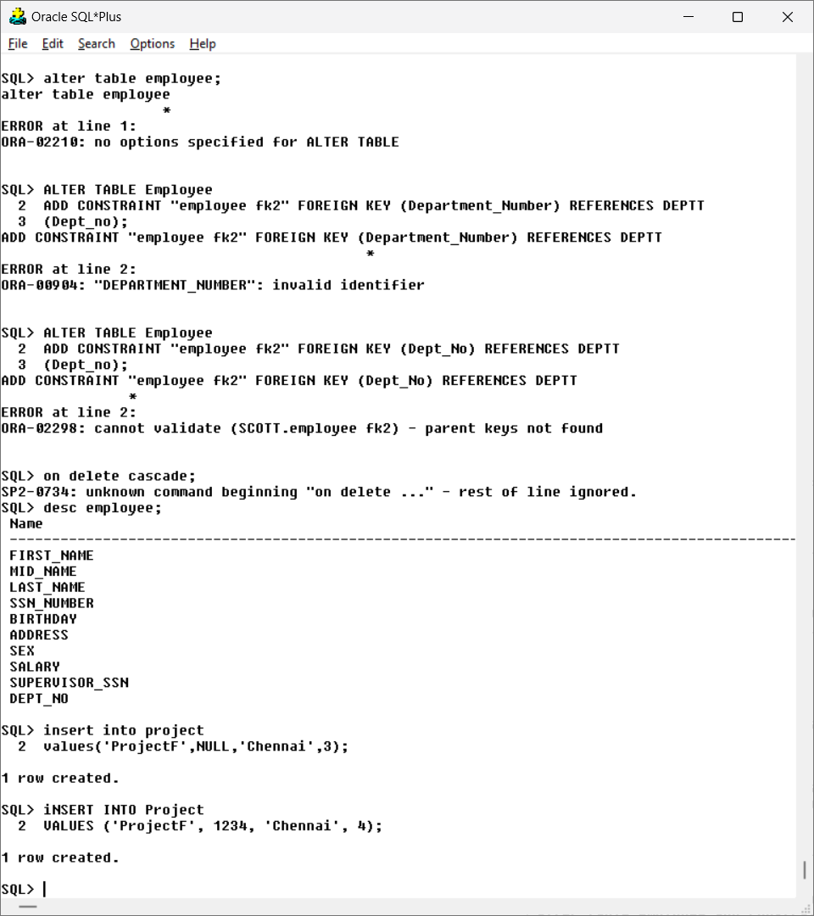

**Alter the tables to**

1. Add Foreign Keys using Alter Table [if not done earlier].

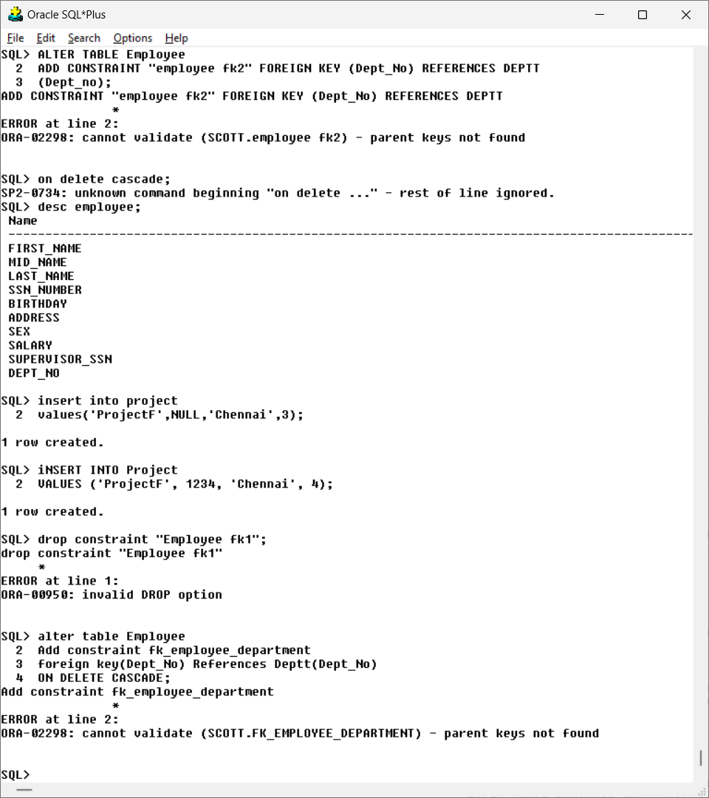

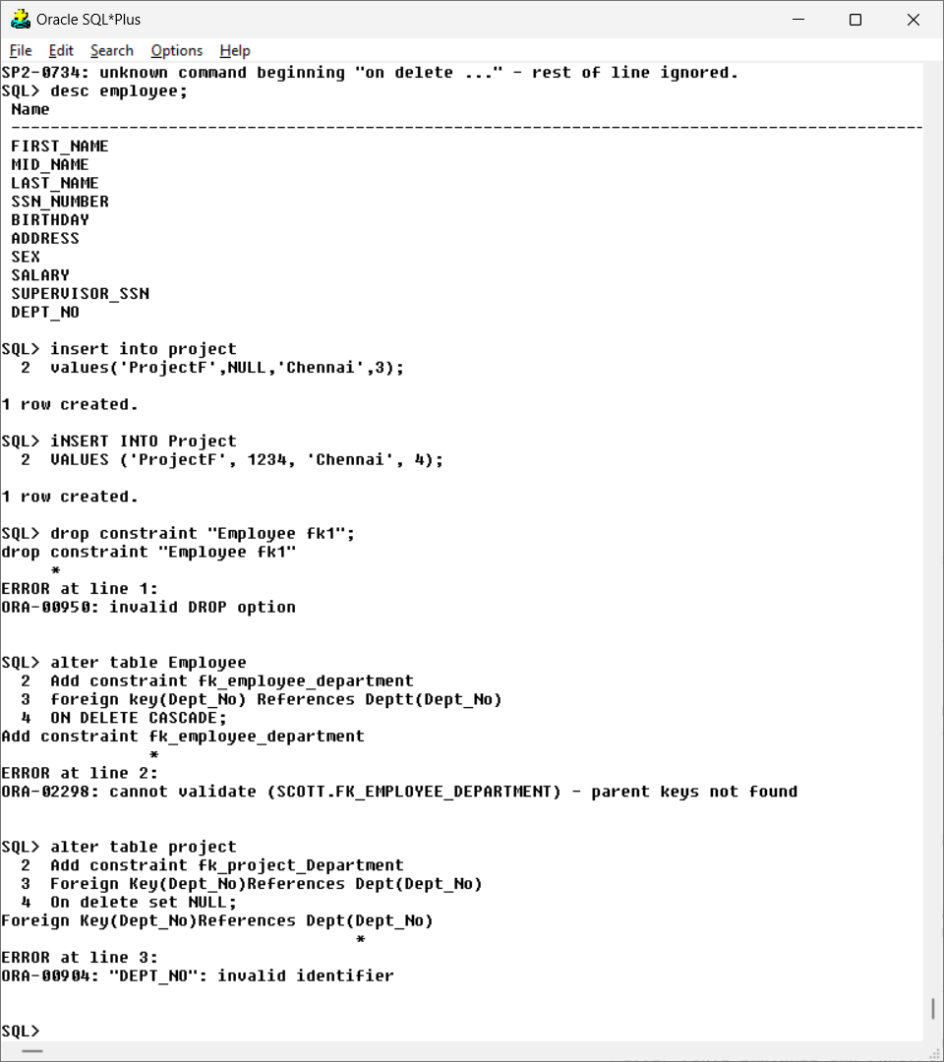

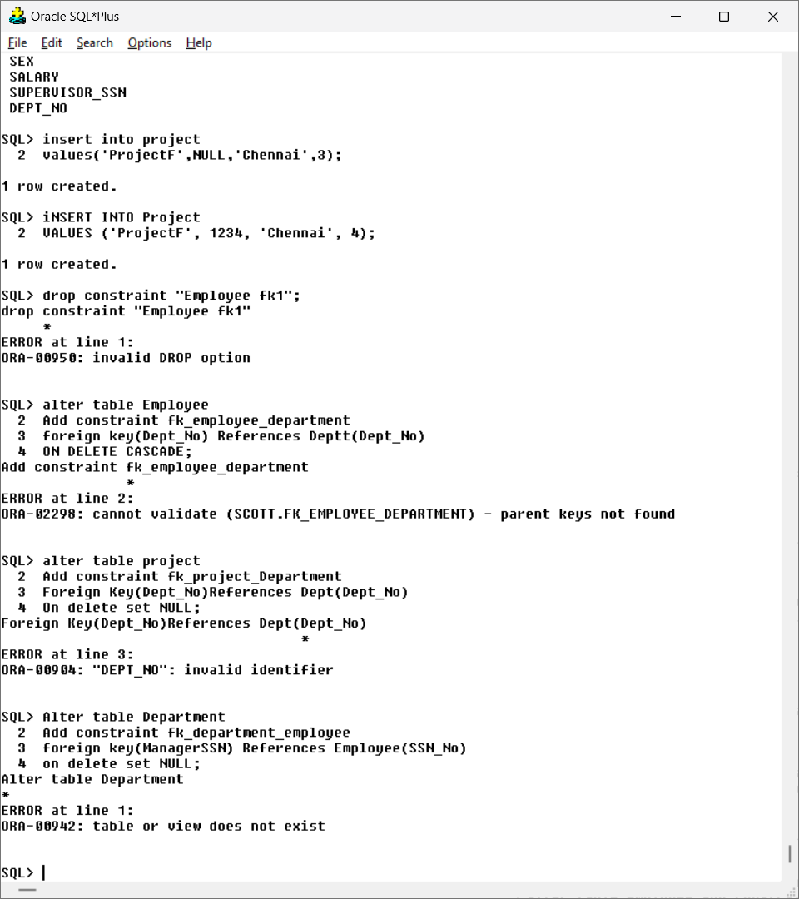

1. Drop Foreign key defined on SuperSSN and add it using Alter table command.

Query:

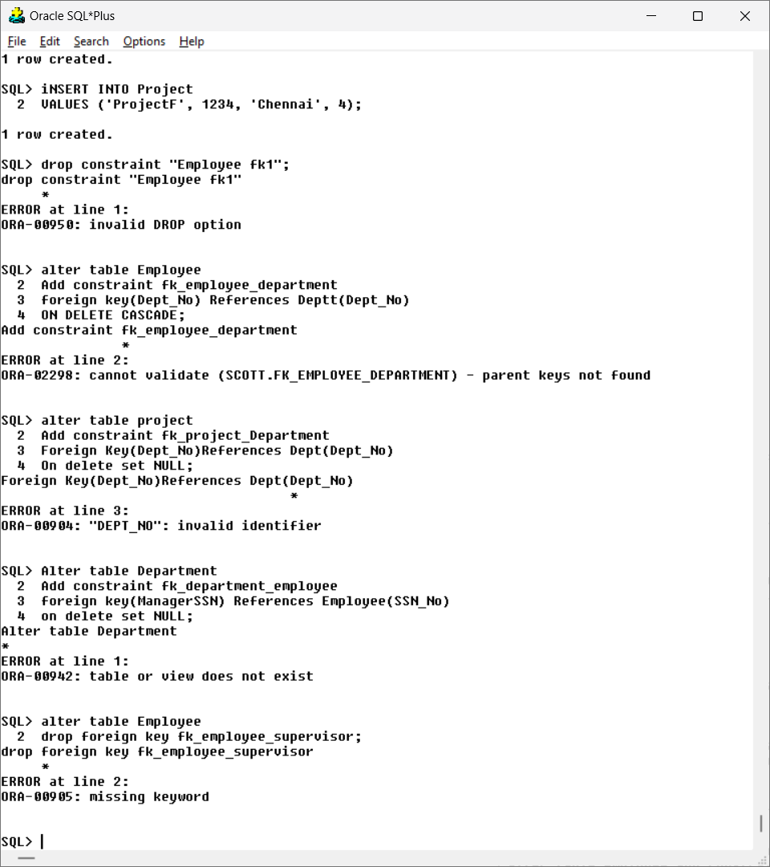3.Make name of Project as Unique and sex of employee as not null.

Query:

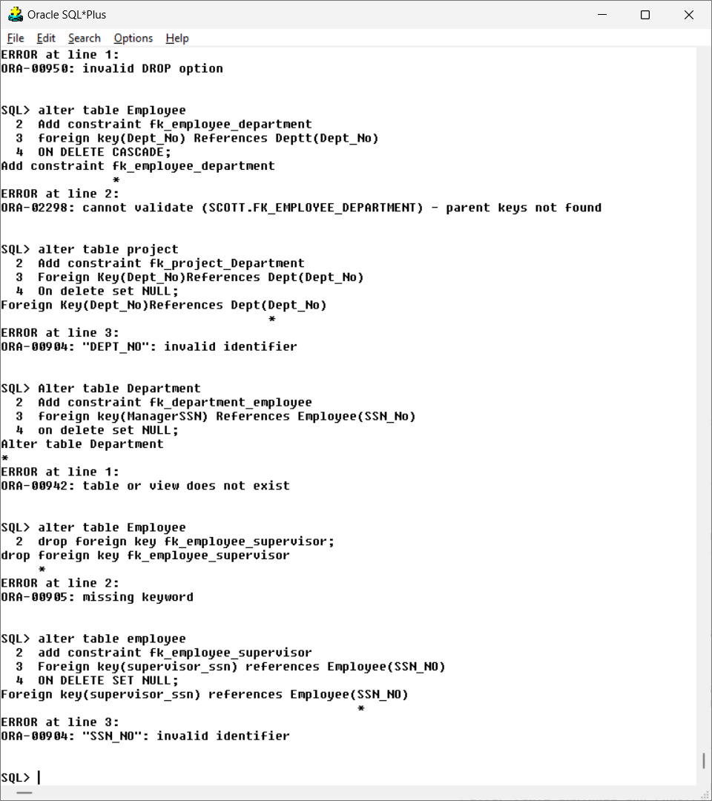

1. In the copy table add the columns door no, street, city, State, Continent.

Query:

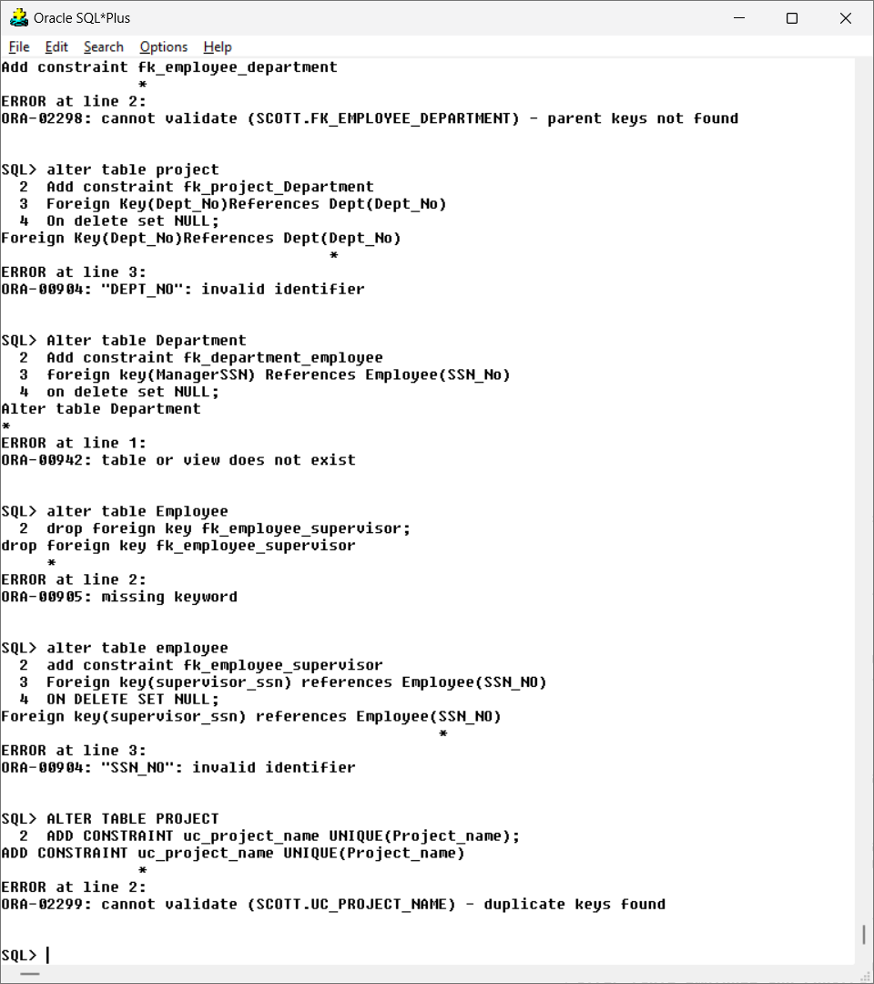

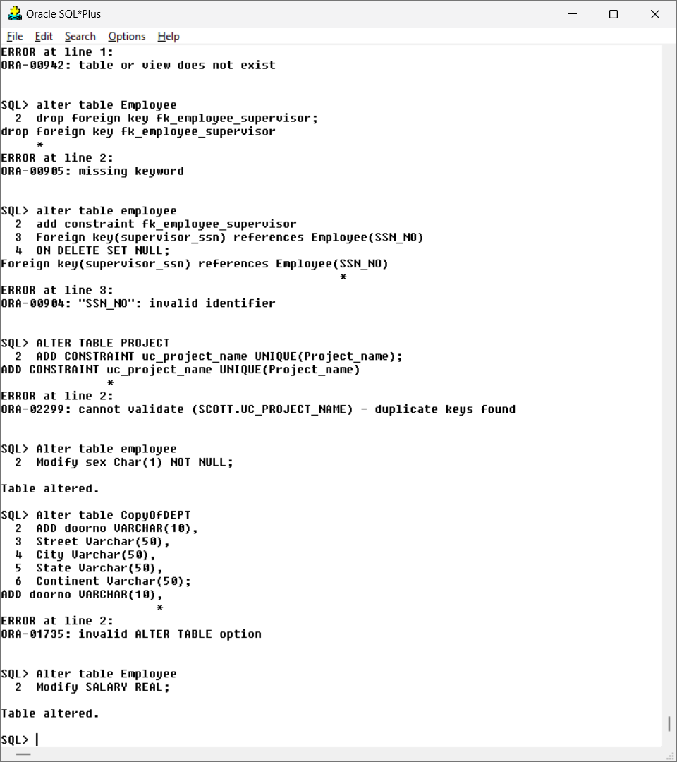



1. Make salary of employee to accept real values.

Query:



**Exercise – 4:**

1. Create the tables described below:

Table Name: Client_Master

Column Name DataType

Clientno Varchar2(6)

Name Varchar2(20)

Address Varchar2(30)

City Varchar2(10)

Pincode Number(8)

State Varchar2(15)

Baldue Number(10,2)

Table Name: Product_Master

Column Name DataType

Productno Varchar2(6)

Description Varchar2(15)

Um(Unitmeasure) Varchar2(10)

QOH(Qty on hand) Number(10)

Reorderlvl Number(5)

Sellprice Number(8,2)

Costprice Number(8,2)

Query and output:

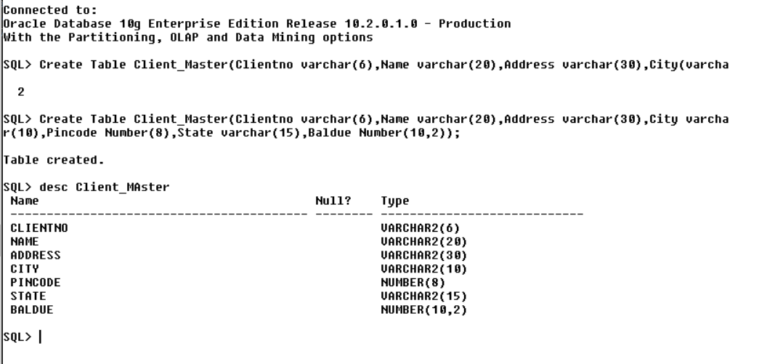

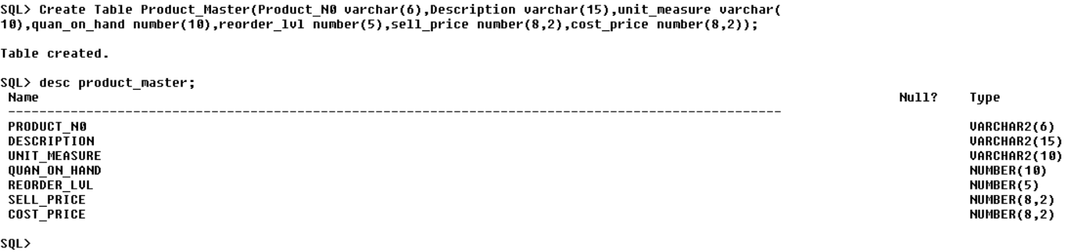

**2. Insert the following data into their respective tables:**

Data for Client_Master table

Clientno Name Address City Pincode State Baldue

C00001 Asha A/14, worli Mumbai 400054 Maharashtra 15000

C00002 Lakshmi 65, Nariman Bangalore 560001 Karnataka 0

C00003 Puja P-76, Bandra Mumbai 400002 Maharashtra 10000

C00004 Shankar A/6, Juhu Mangalore 400044 Karnataka 5000

C00005 Deepak 68, TNagar Chennai 6320018 Tamilnadu 0

Data for Product_Master table

Productno Description Um QOH Reorderlvl Sellprice Costprice

P00001 T-Shirts Piece 200 40 350 250

P0345 Shirts Piece 150 50 500 350

P06744 Cotton Jeans Piece 50 20 600 450

P0990 Chuddy Piece 100 40 400 250

P08823 Sarries Piece 60 50 500 300

Query and output:

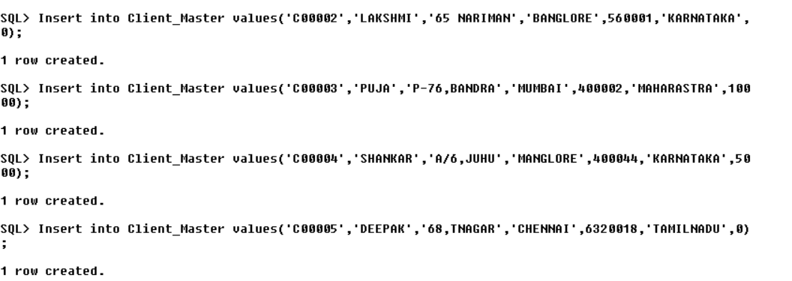

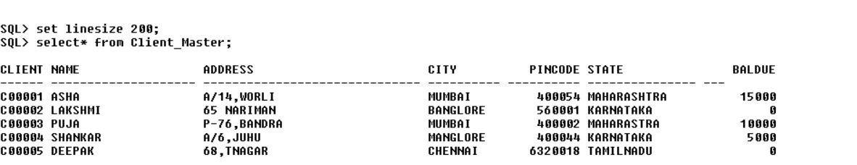

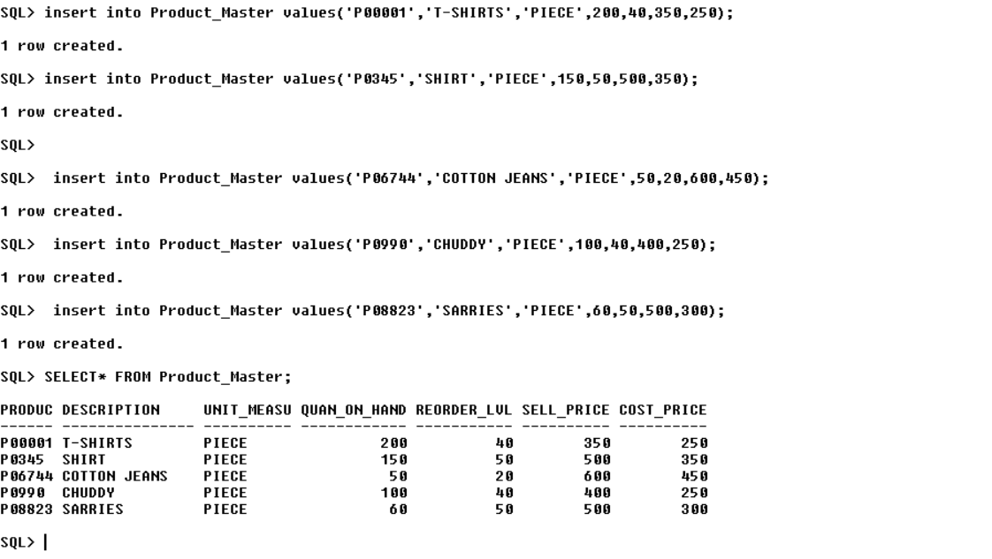

**3. Retrieving records from a table**

a. Find out the names of all the clients

Query and output:

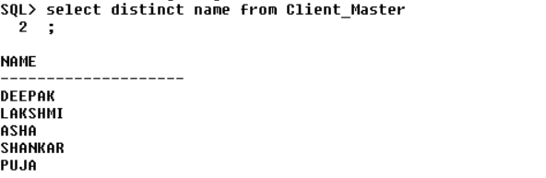

b. Retrieve the entire contents of the Client_Master table

Query and output:

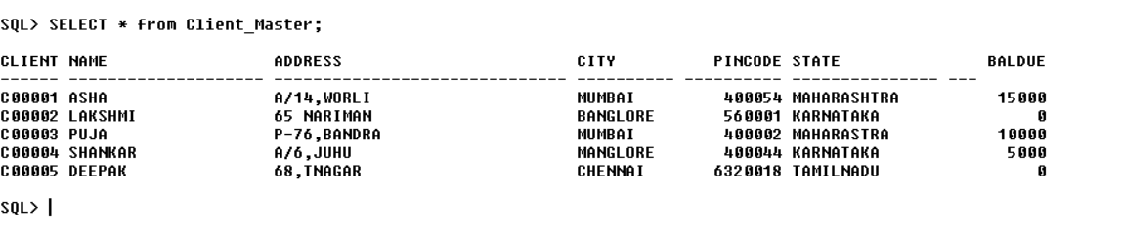

c. Retrieve the list of names, city and the state of all the clients

Query and output:

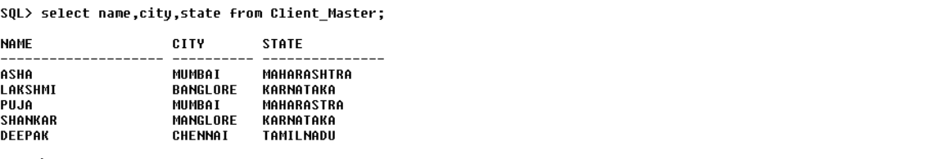

d. List the various products available from the Product_Master table.

Query and output:

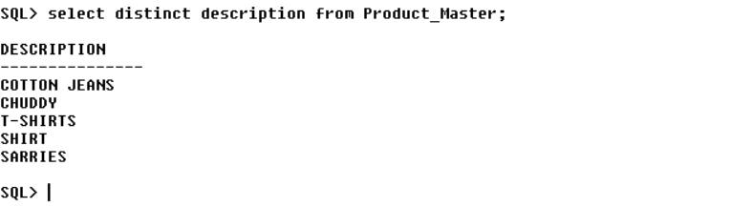

e. List all the clients who are located in Mumbai.

Query and output:

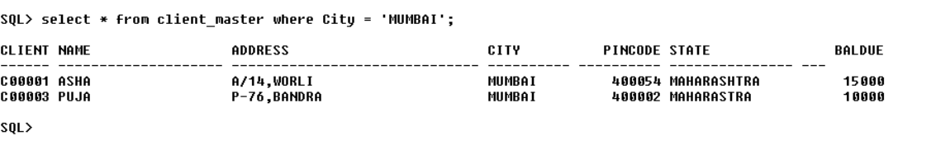

**4. Updating records in a table**

a. Change the City of Clientno ‘C00001’ to ‘Chennai’

Query and output:

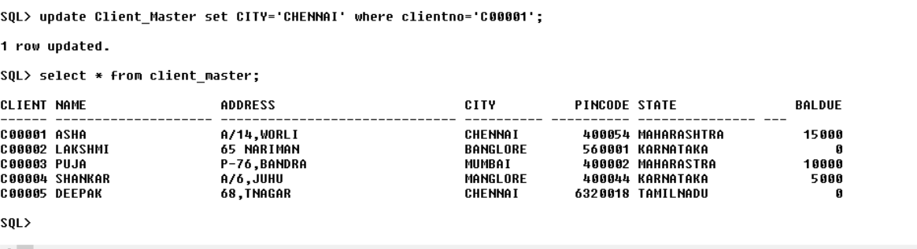

b. Change the Baldue of Clientno ‘C00005’ to Rs.1000

Query and output:



c. Change the cost price of ‘shirts’ to Rs. 400

Query and output:

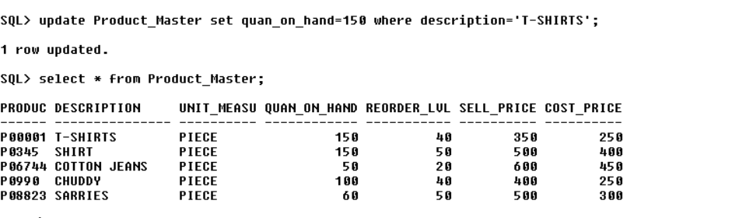

d. Change the QOH of the ‘T-shirts’ to 150

Query and output:



**5. Deleting records in a table**

a. Delete all products from Product_Master where the quantity on hand is equal to 100

Query and output:

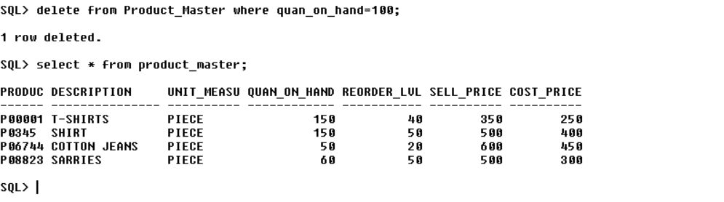

b. Delete from Client_Master where the column state holds the value “Tamilnadu”

Query and output:

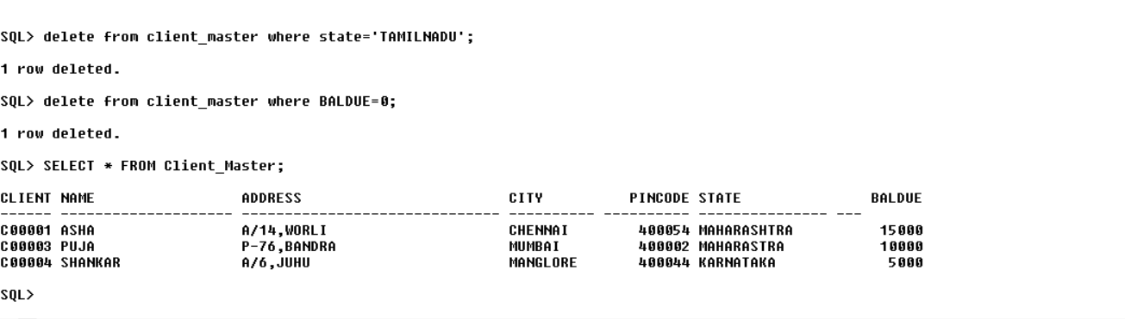

c. Delete all clients from Client_Master where the Baldue is equal to 0.

**6. Altering the table structure**

a. Add a column call Profitpercent of datatype number10,2 to the Product_Master

Query and output:



b. Change the size of sellprice column in Product_Master to 10,2

Query and output:

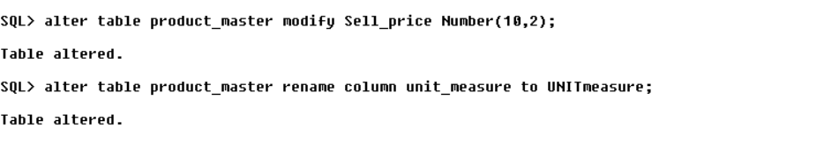

c. Change the name of the column UM to UnitMeasure in Product_Master

Query and output:



d. Drop the column UnitMeasure.

Query and output:

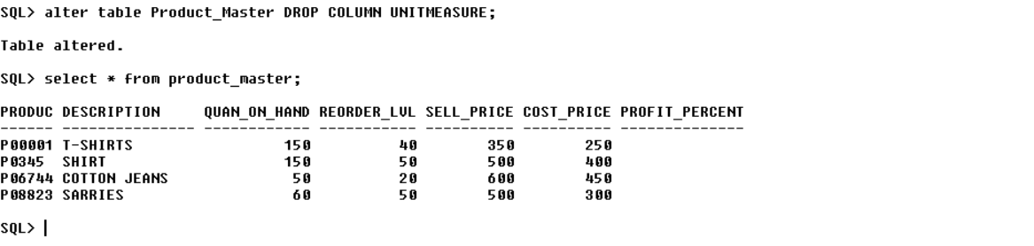

e. Drop the table Client_Master along with its data

Query and output:

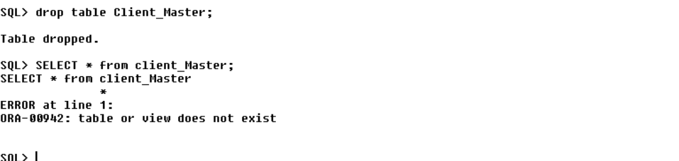

**Exercise 5:**

**Aim: To understand different operators in SQL**

1. Find the employee names having salary greater than Rs.45000.

Query:

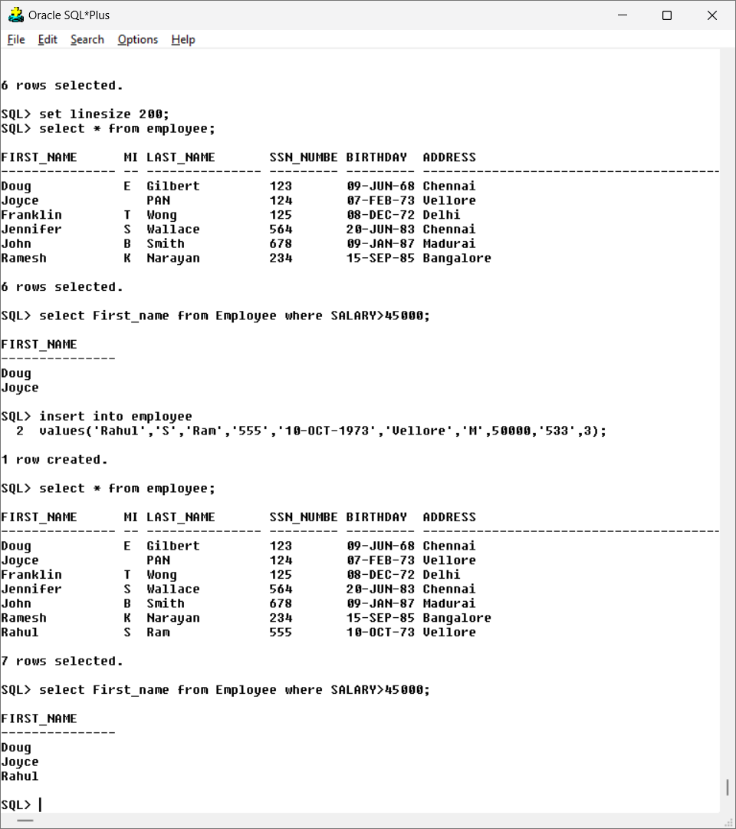

Output:



2. Find the employee names whose salary lies in the range between 35000 and

75000.

Query:

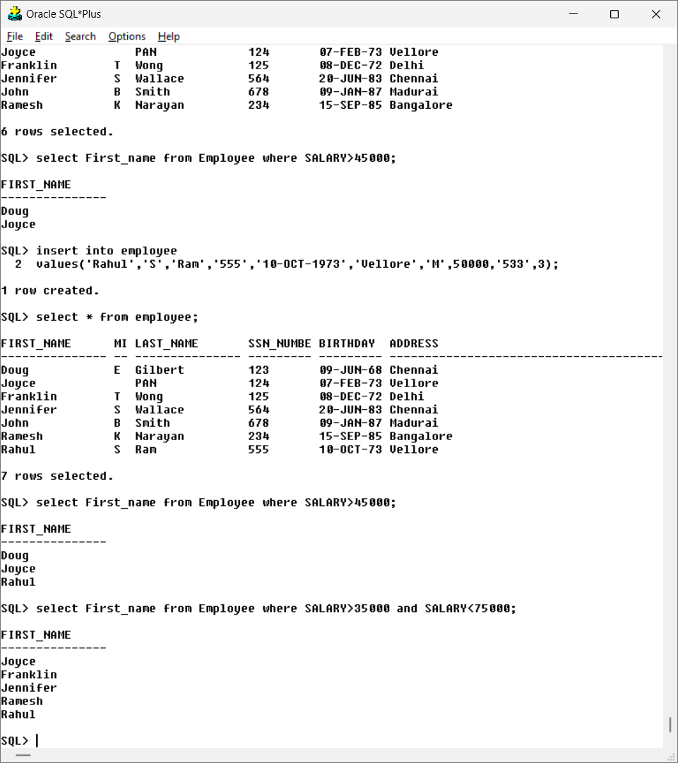

Output:



1. Find the employees who have no supervisor.

Query:

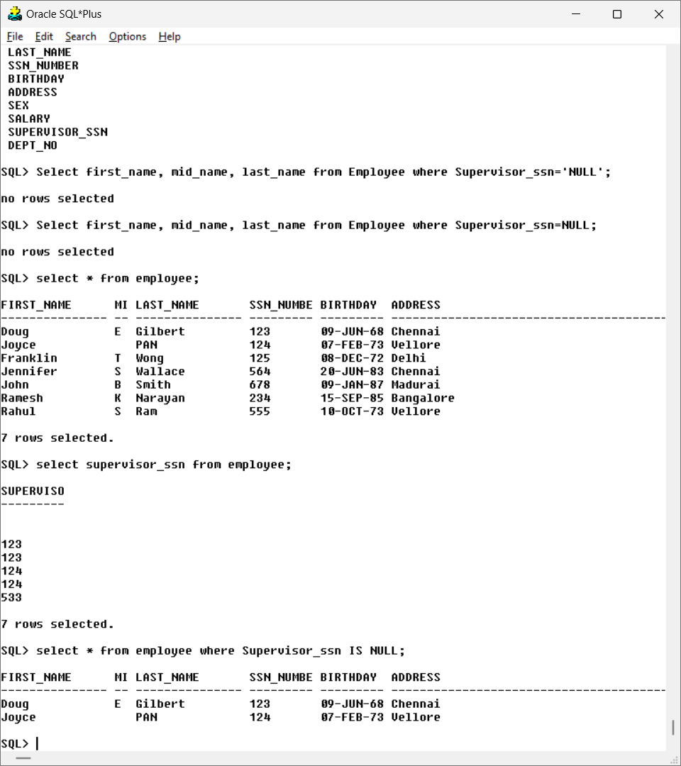

Output:



1. Display the employee names having ‘salt lake’ in their address.

Query:

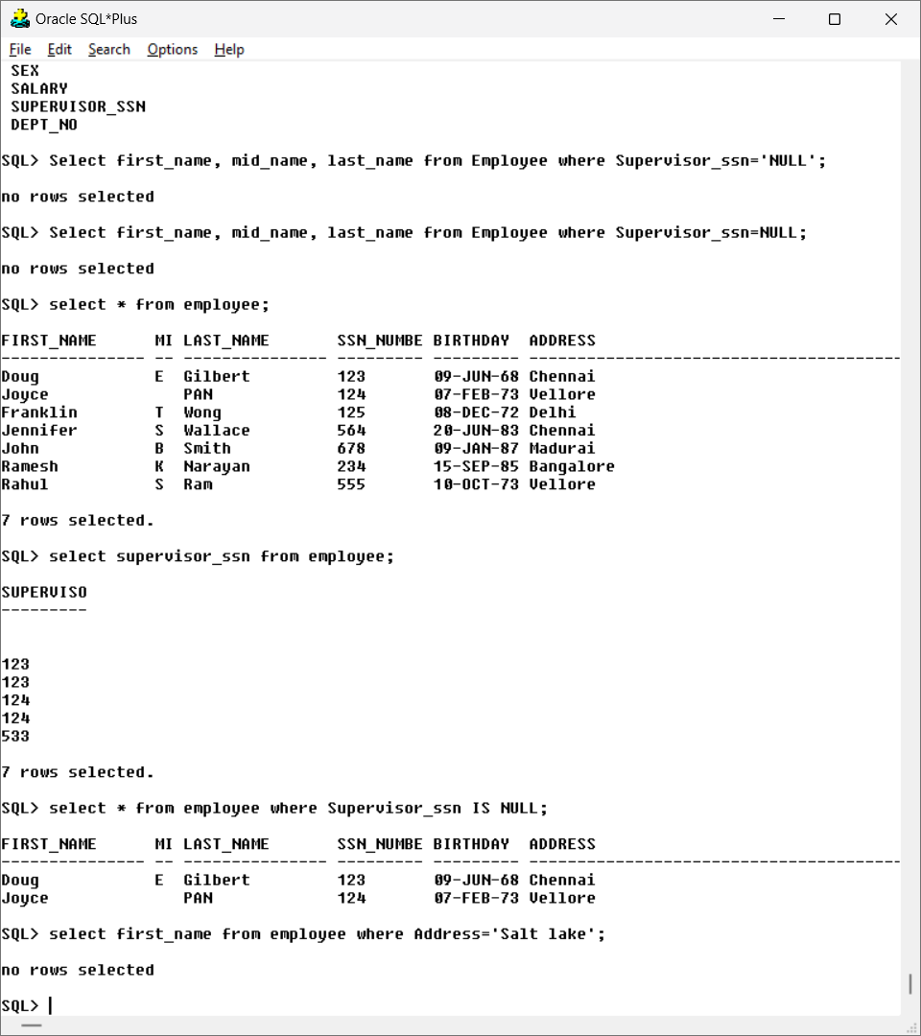

No output.

5.Display the department name that starts with ’H’.

Query:

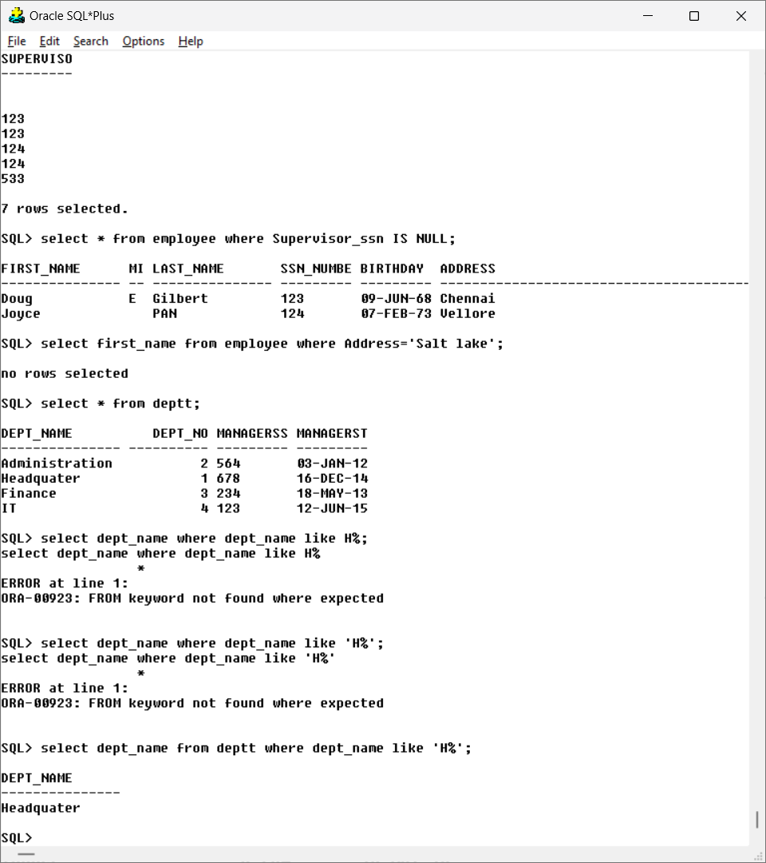

Output:



6. Display the project numbers along project name that ends with ‘i’ in project location.

Query:

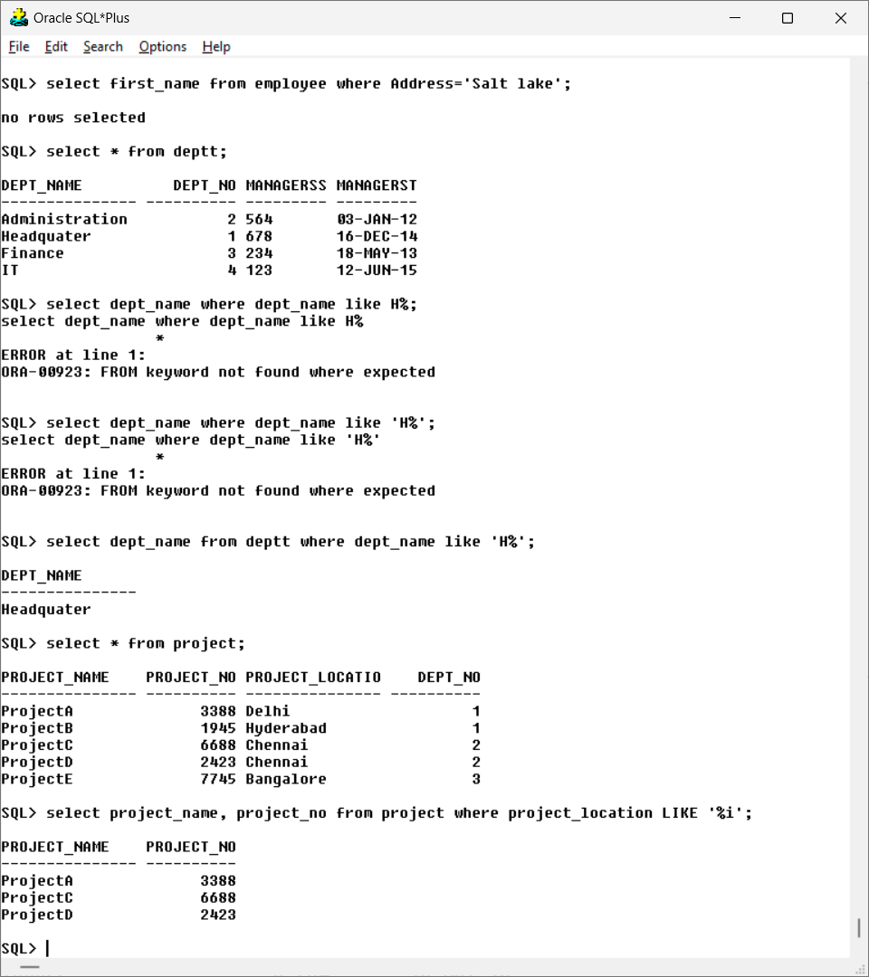

Output:



7. Display the names of all the employees having supervisor with any of the following SSN 123, 533.

Query:

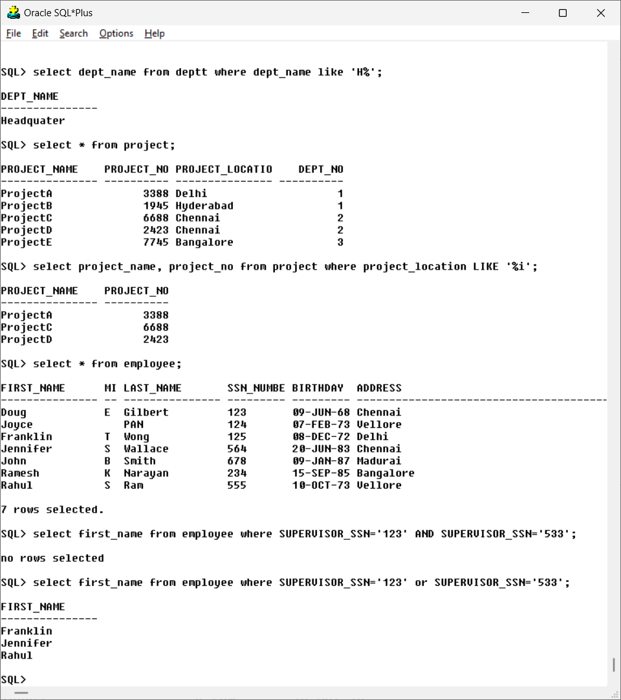

Output:



8. Display all the employee details based on the salary in descending order.

Query:

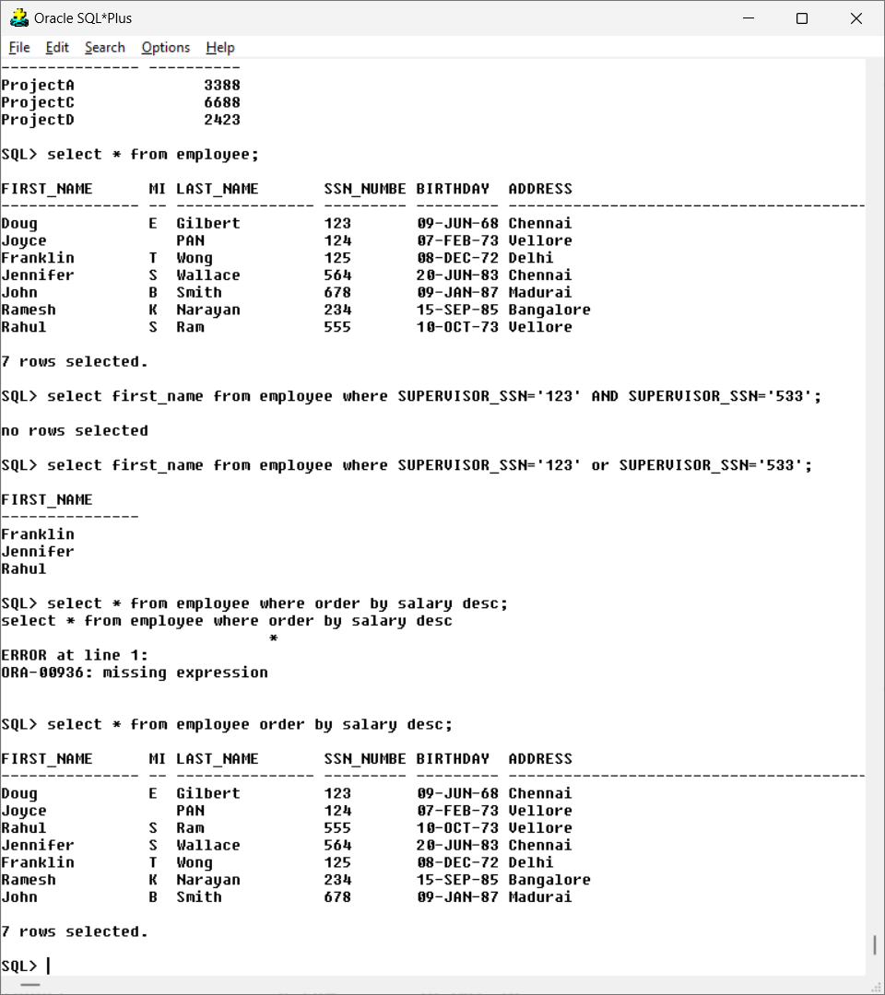

Output:



9. Display the employees belongs to Chennai or vellore.

Query:

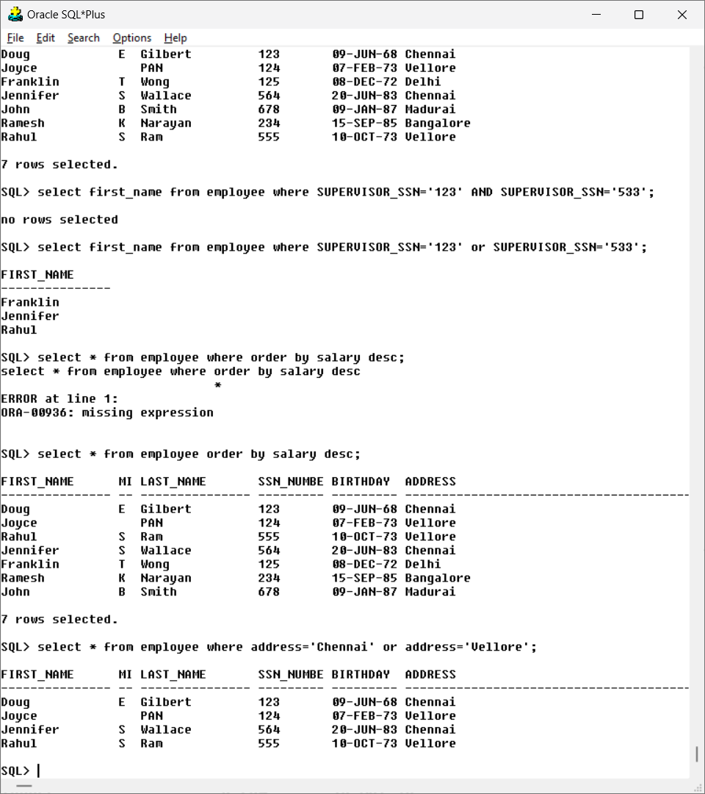

Output:



10.Display the department details in ascending order of department number.

Query:

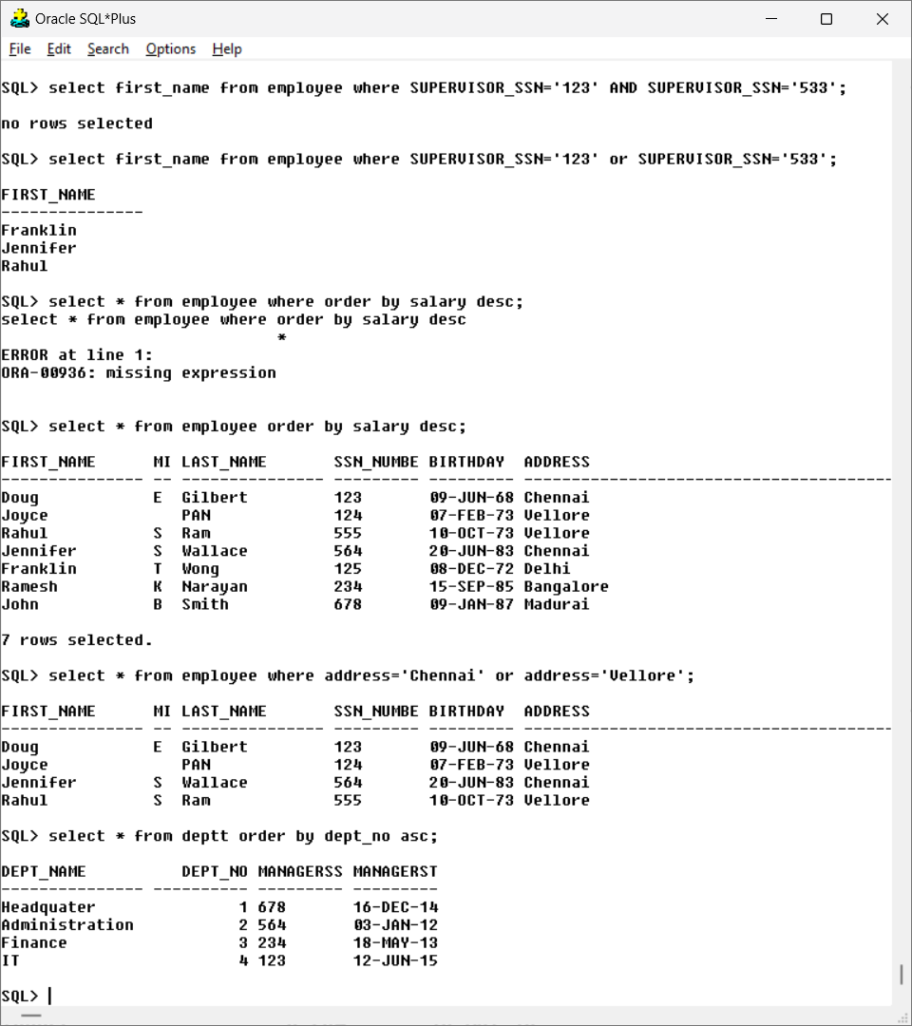

Output:



11.Display all the MgrSSN and MgrStartDate as ManagerSSN and Manager_DOJ.

Query:

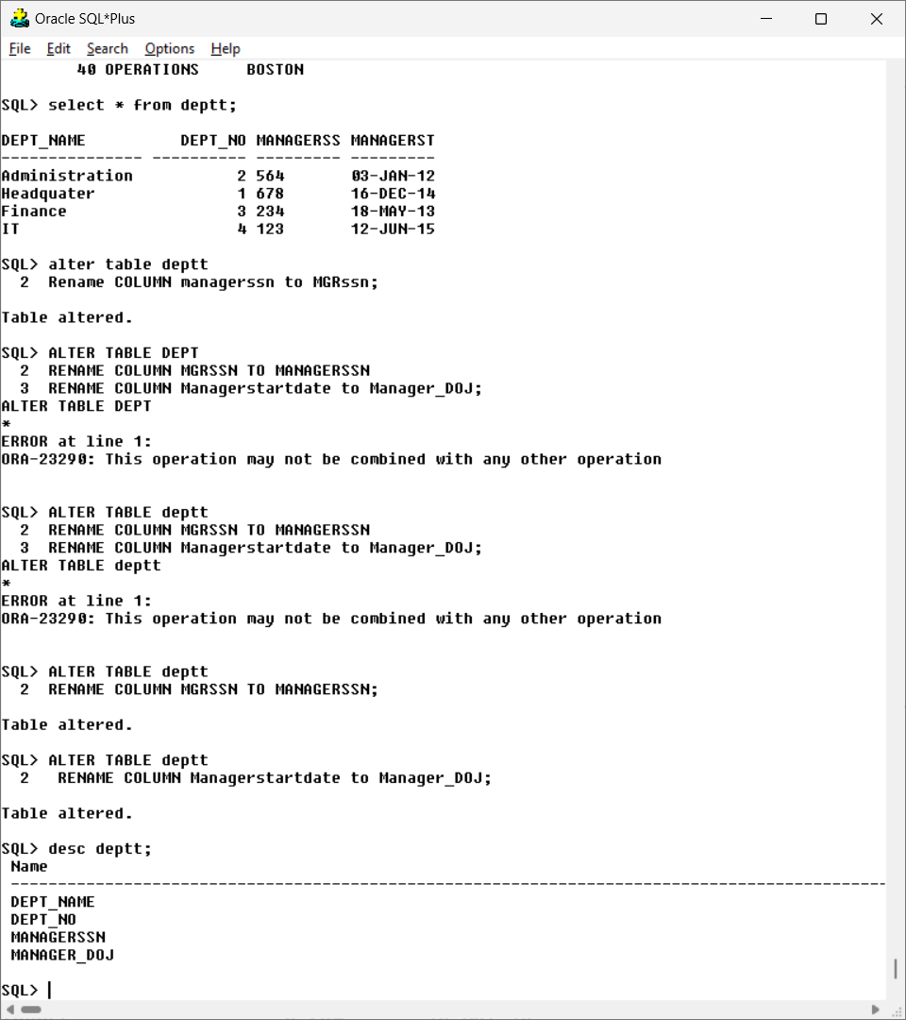

Output:



12.Display all the male employees with SSN and salary

Query:

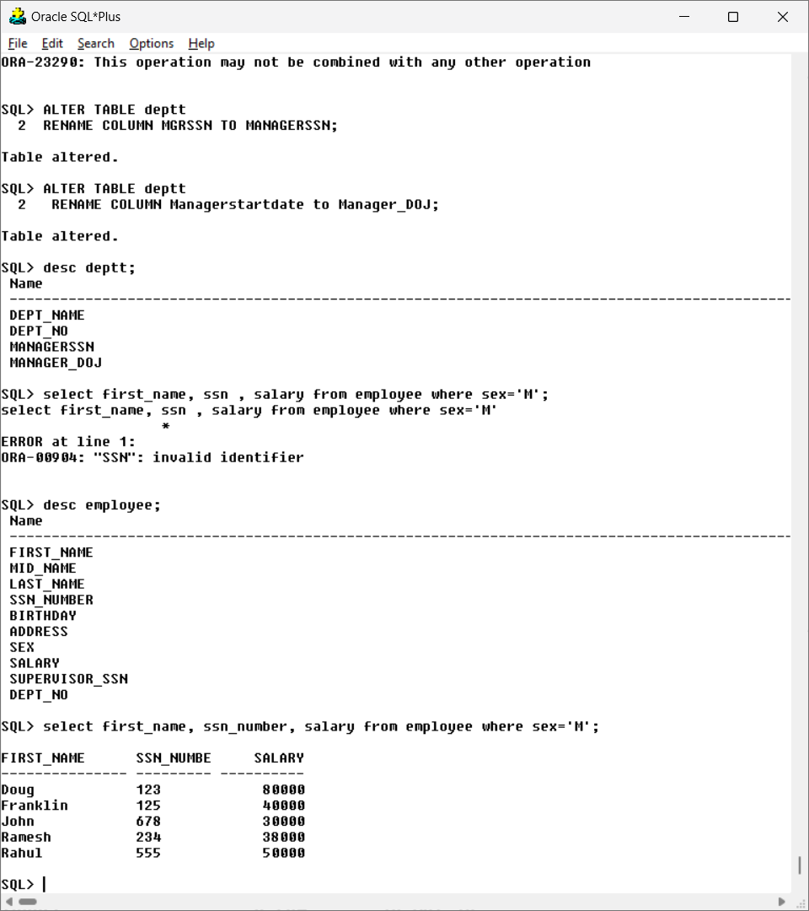

Output:

